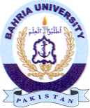
Bahria University Library Islamabad
Source: The News & Express, Sunday June 05, 2022

