
Bahria University Library Islamabad
Source: The News, Tuesday May 31, 2022

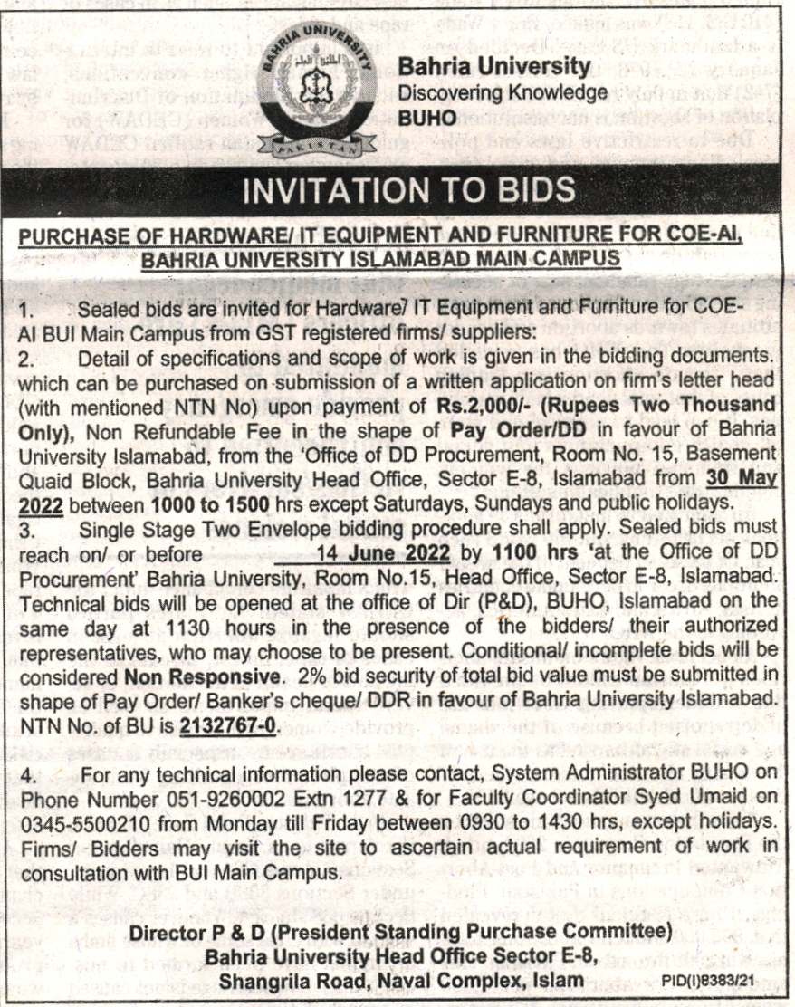

Bahria University Library Islamabad
Source: Express, Tuesday May 31, 2022

