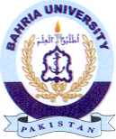
Bahria University Library Islamabad
Source: Express Tribune, Friday June 03, 2022

