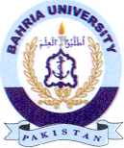
Bahria University Library Islamabad
Source: Jang, Thursday June 02, 2022

