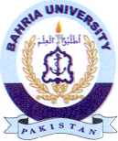
Bahria University Library Islamabad
Source: Dawn, Friday May 20, 2022

