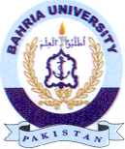
Bahria University Library Islamabad
Source: Express Tribune, Friday May 13, 2022

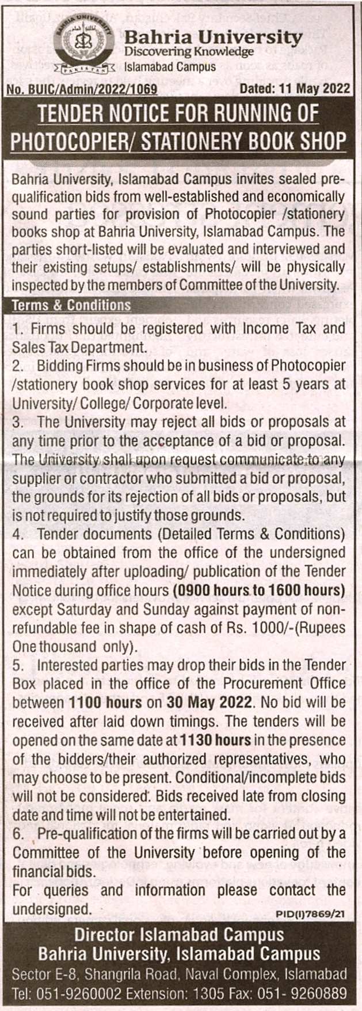

Bahria University Library Islamabad
Source: Jang, Friday May 13, 2022

