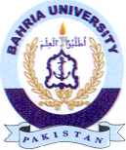
Bahria University Library Islamabad
Source: The News & Nawa-i-Waqt, Tuesday May 10, 2022

