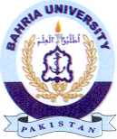
Bahria University Library Islamabad
Source: Express Tribune, Saturday April 23, 2022

