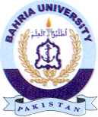
Bahria University Library Islamabad
Source: The Nation, Friday April 22, 2022

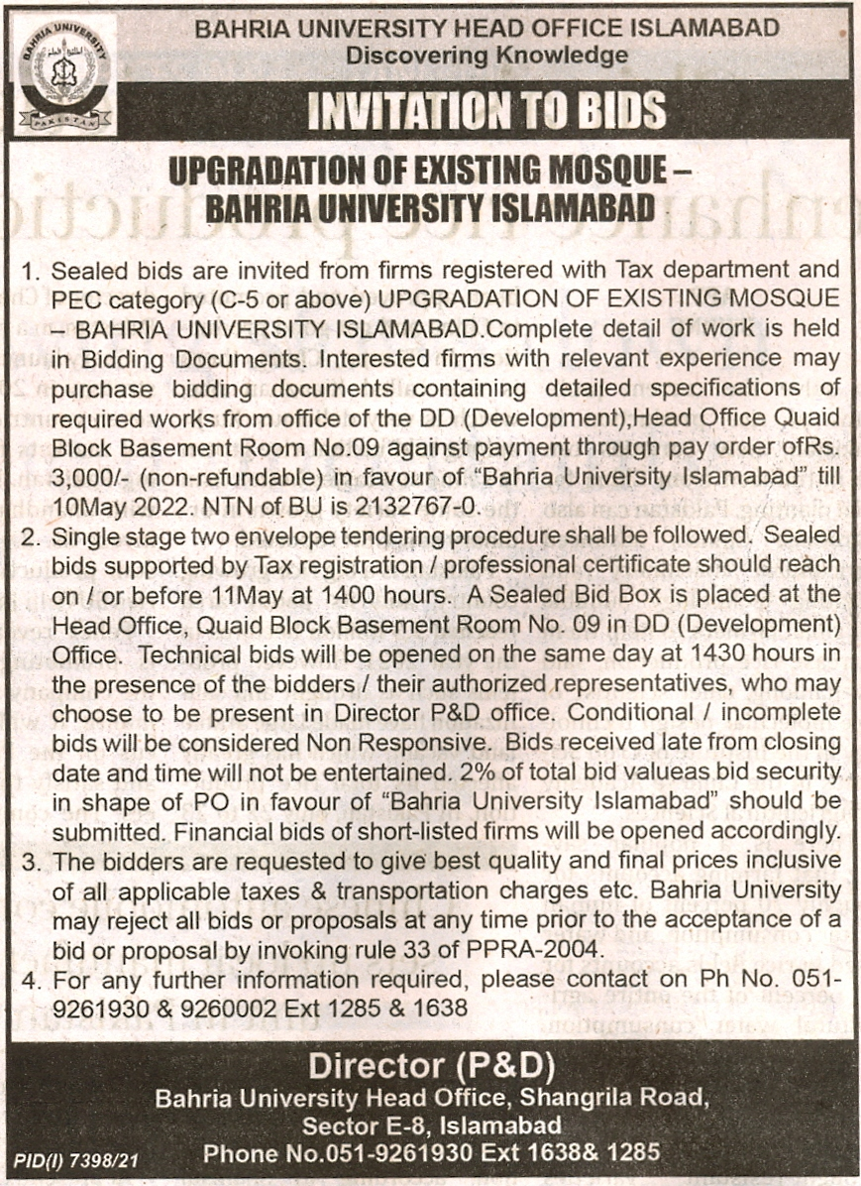

Bahria University Library Islamabad
Source: Express, Friday April 22, 2022

