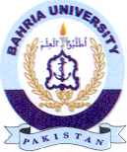
Bahria University Library Islamabad
Source: Dawn & Dunya, Sunday April 10, 2022

