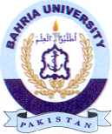
Bahria University Library Islamabad
Source: Nawa-i-Waqt, Sunday April 10, 2022

