
Bahria University Library Islamabad
Source: The News, Saturday April 02, 2022

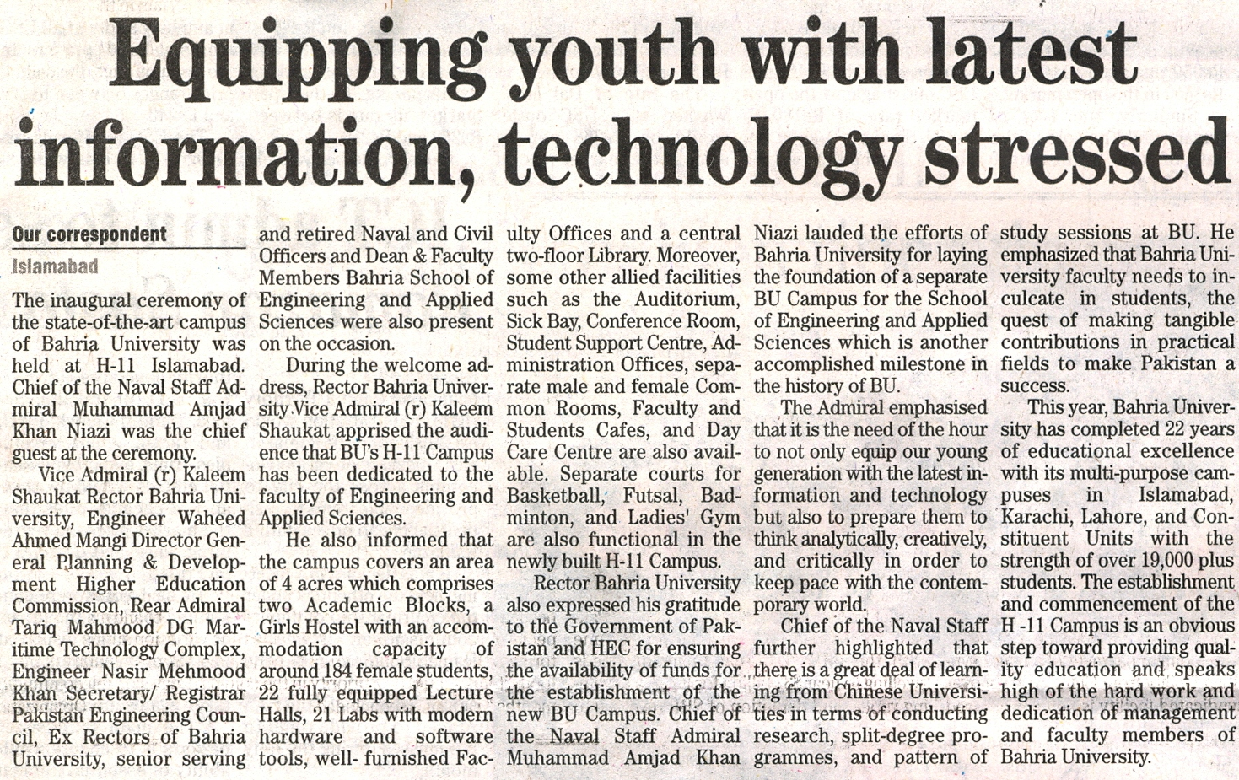

Bahria University Library Islamabad
Source: Pak Observer, Saturday April 02, 2022

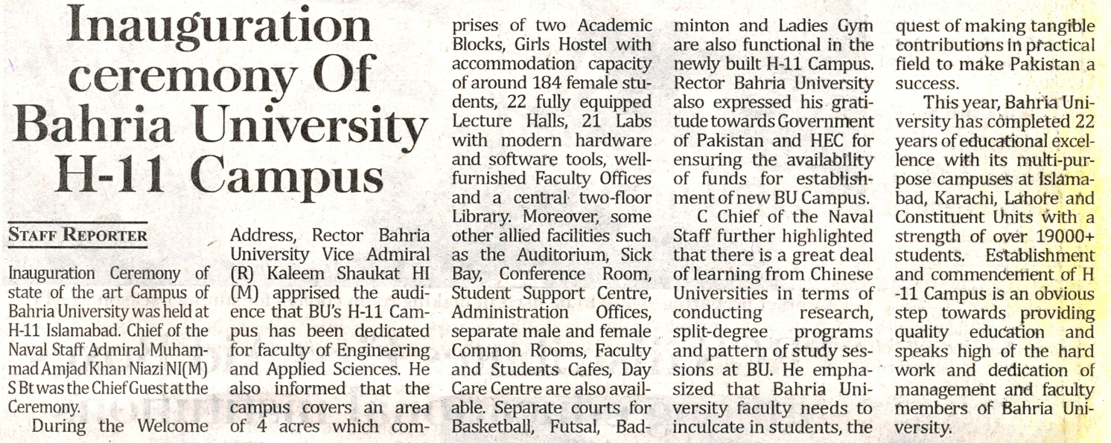

Bahria University Library Islamabad
Source: Daily Time, Saturday April 02, 2022

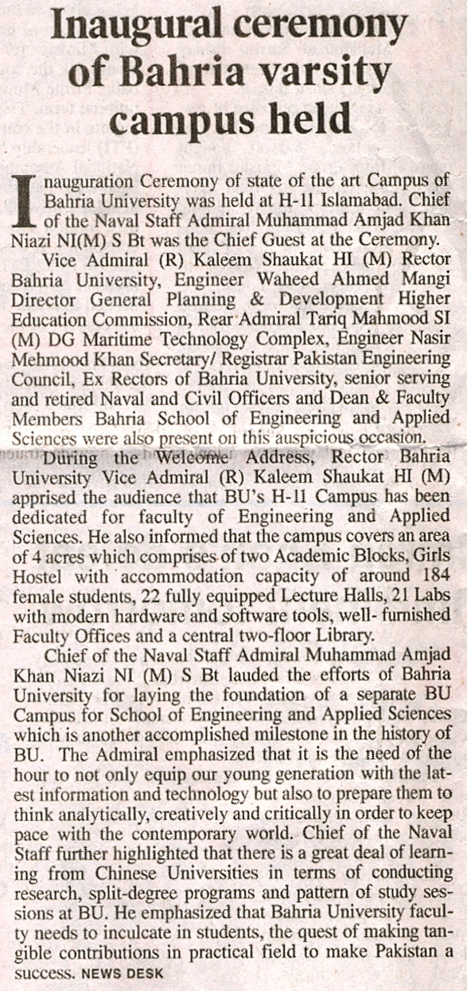

Bahria University Library Islamabad
Source: Dunya, Saturday April 02, 2022

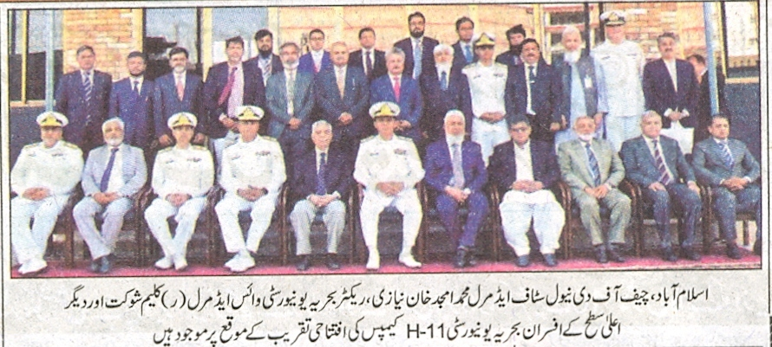
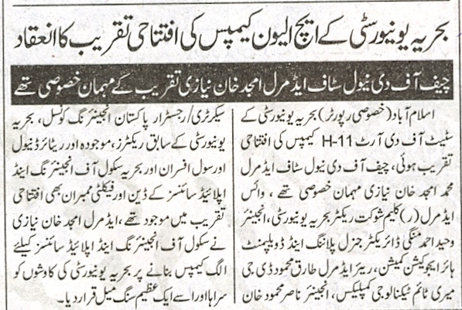

Bahria University Library Islamabad
Source: Nai Baat, Saturday April 02, 2022

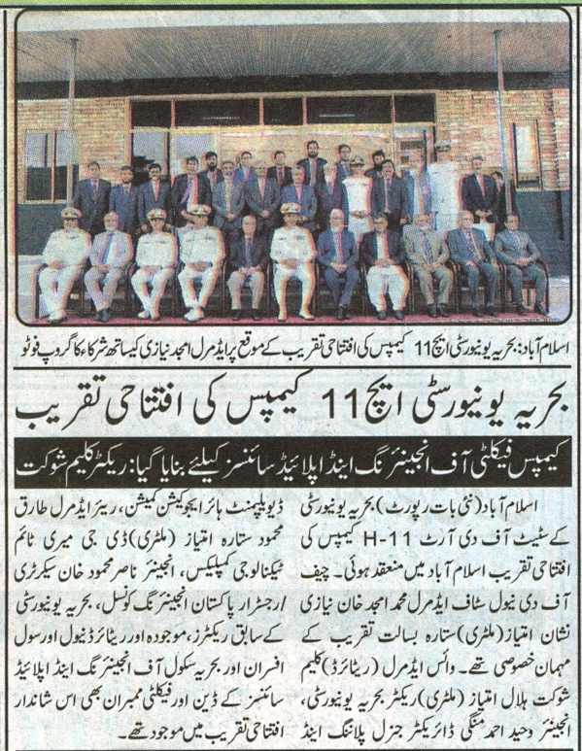

Bahria University Library Islamabad
Source: Nawa-i-Waqt, Saturday April 02, 2022

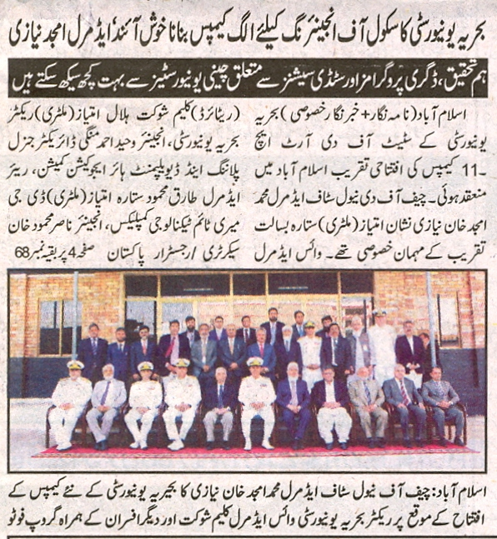
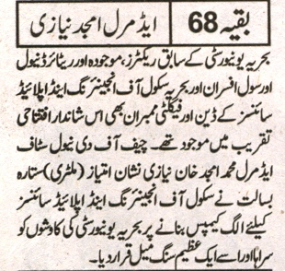

Bahria University Library Islamabad
Source: Express, Saturday April 02, 2022

