
Bahria University Library Islamabad
Source: Pakistan Observer, Wednesday March 10, 2022



Bahria University Library Islamabad
Source: Daily Time, Wednesday March 10, 2022



Bahria University Library Islamabad
Source: Dunya, Wednesday March 10, 2022

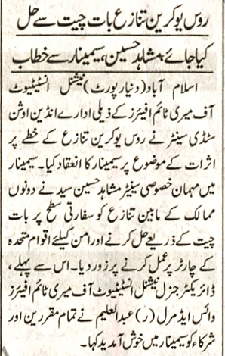

Bahria University Library Islamabad
Source: Jang, Wednesday March 10, 2022

