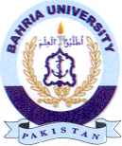
Bahria University Library Islamabad
Source: The Nation, Wednesday March 02, 2022

