
Bahria University Library Islamabad
Source: The News Friday, February 25, 2022

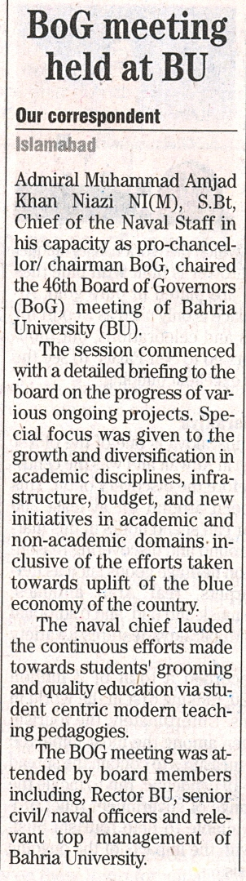

Bahria University Library Islamabad
Source: Dawn, Friday, February 25, 2022

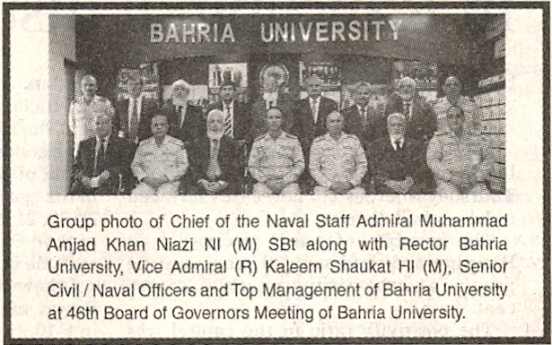

Bahria University Library Islamabad
Source: Pak Observer, Friday, February 25, 2022

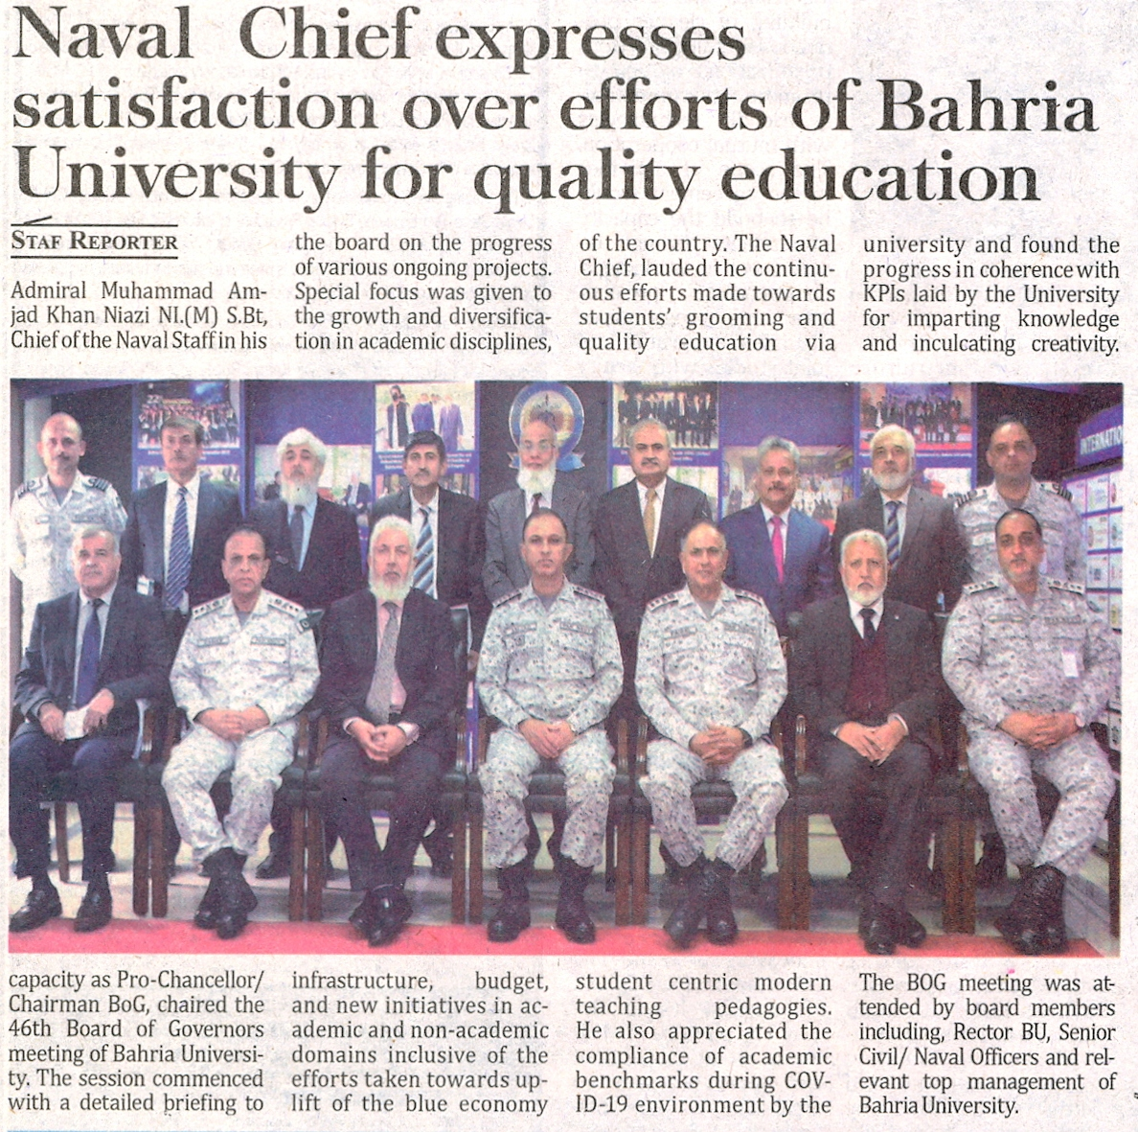

Bahria University Library Islamabad
Source: Daily Times, Friday, February 25, 2022

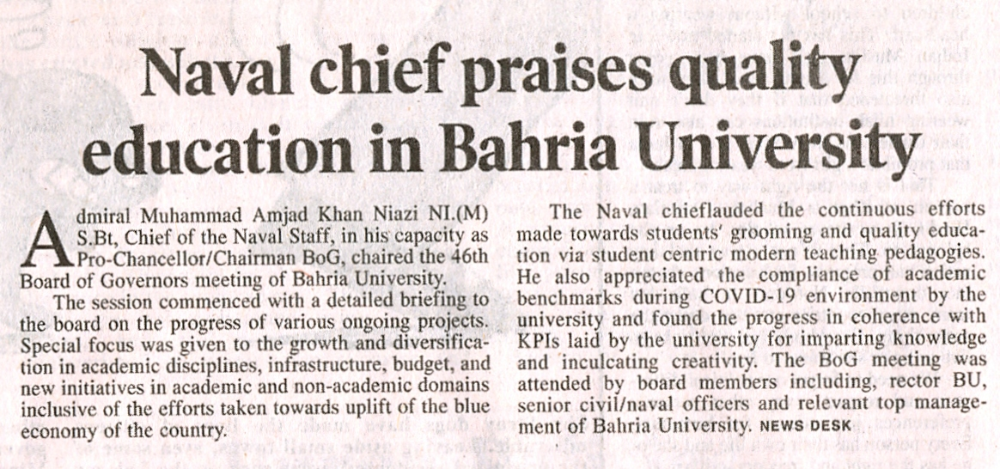

Bahria University Library Islamabad
Source: Jang, Friday, February 25, 2022

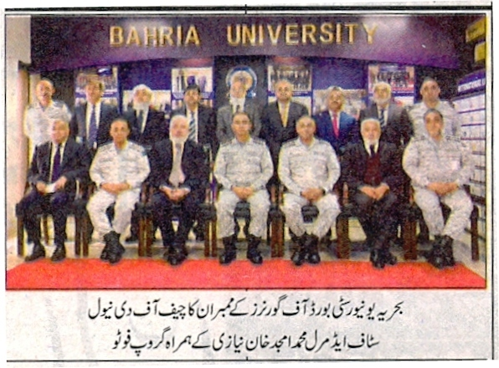

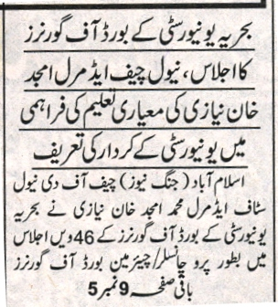
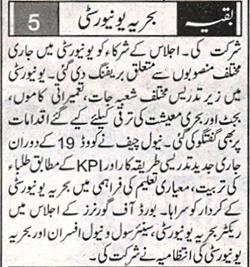

Bahria University Library Islamabad
Source: Express, Friday, February 25, 2022

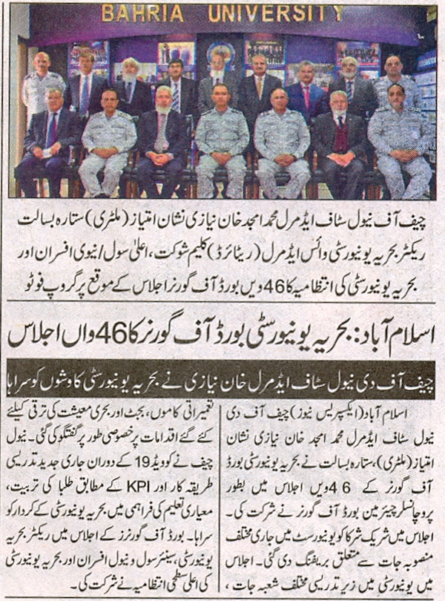

Bahria University Library Islamabad
Source: Dunya, Friday, February 25, 2022

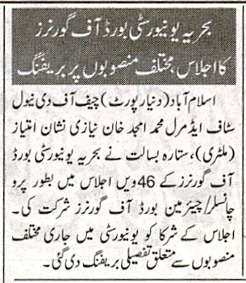

Bahria University Library Islamabad
Source: Nai Baat, Friday, February 25, 2022

