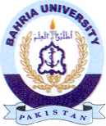
Bahria University Library Islamabad
Source: Express Tribune, Sunday, February 27, 2022

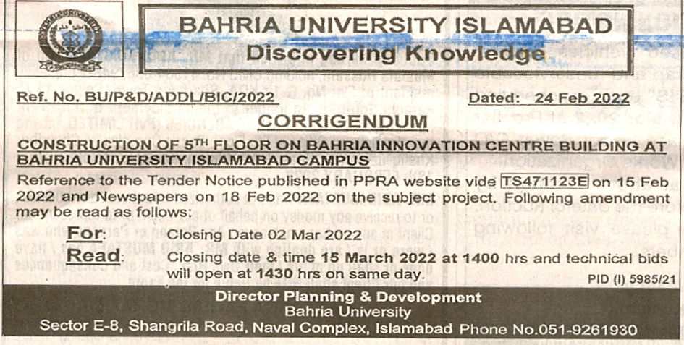

Bahria University Library Islamabad
Source: Nawa-i-Waqt, Sunday, February 27, 2022

