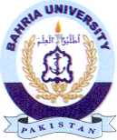
Bahria University Library Islamabad
Source: Dawn, Sunday, February 27, 2022

