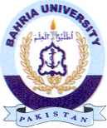
Bahria University Library Islamabad
Source: Express Tribune & Nawa-i-Waqt, Sunday January 30, 2022

