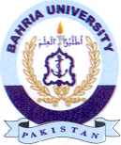
Bahria University Library Islamabad
Source: The News & Jang, Sunday January 23, 2022

