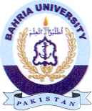
Bahria University Library Islamabad
Source: The News, Thursday January 13, 2022

