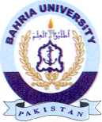
Bahria University Library Islamabad
Source: The News, Sunday January 09, 2022

