
Bahria University Library Islamabad
Source: The Frontier Post, Sunday January 09, 2022

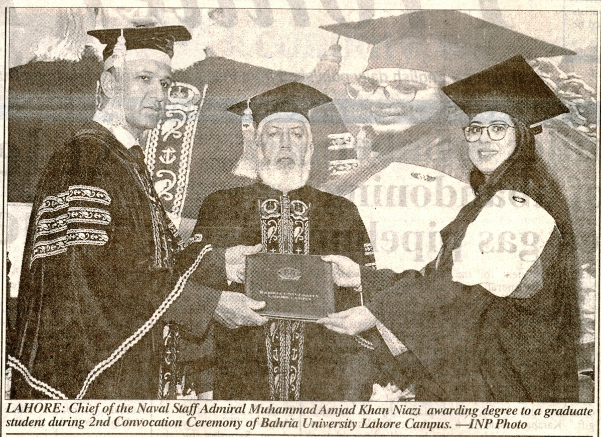

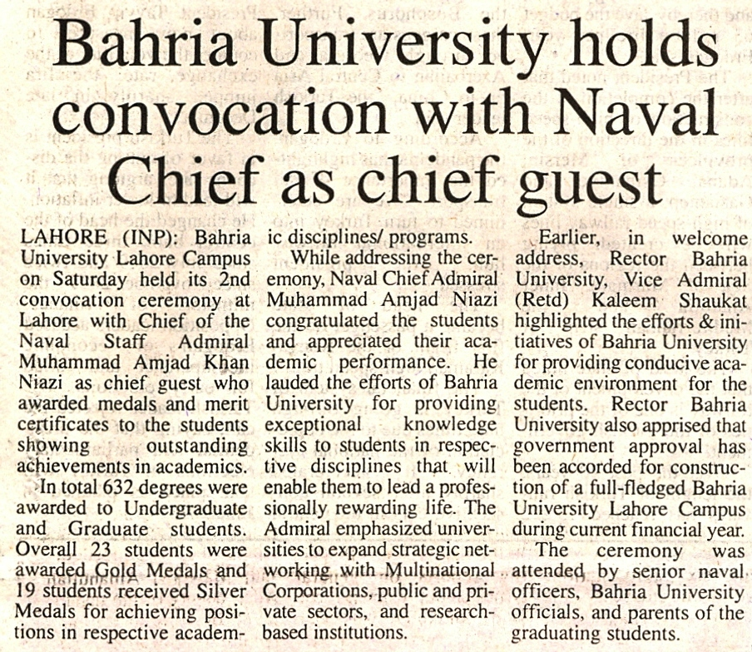

Bahria University Library Islamabad
Source: The Nation, Sunday January 09, 2022

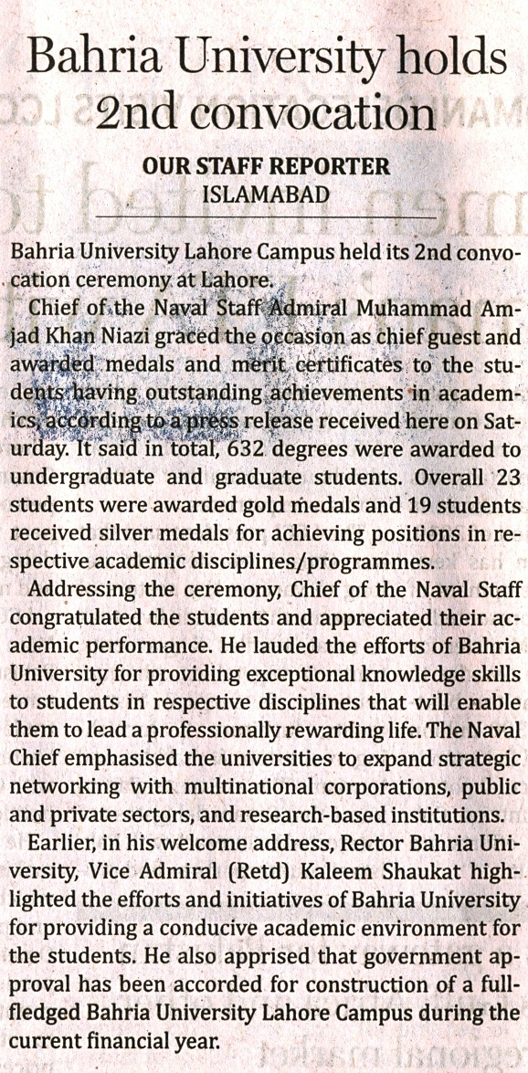

Bahria University Library Islamabad
Source: Dunya, Sunday January 09, 2022

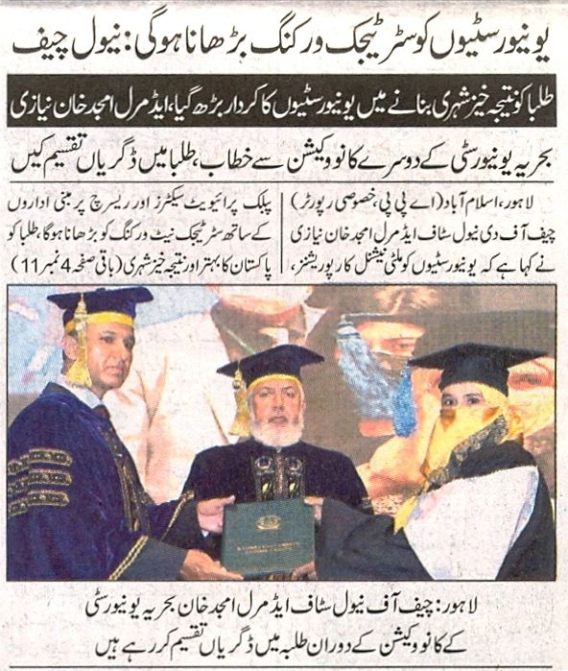

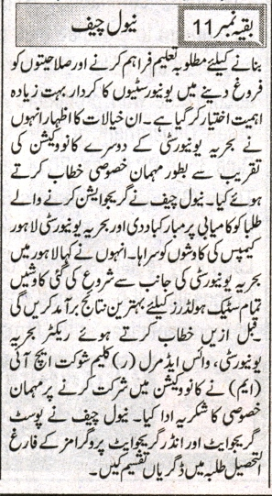

Bahria University Library Islamabad
Source: Jang, Sunday January 09, 2022

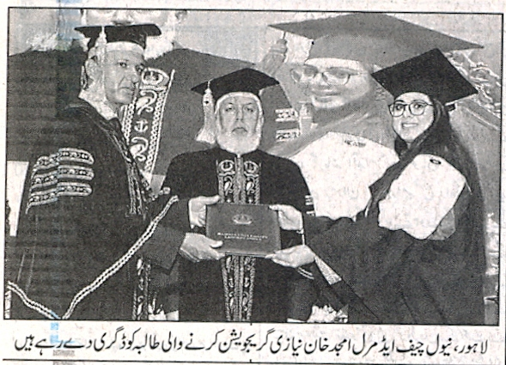

Bahria University Library Islamabad
Source: Nai Baat, Sunday January 09, 2022

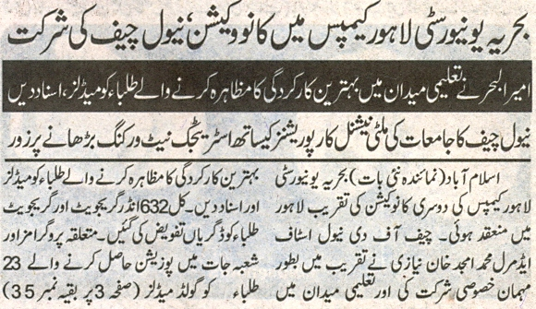

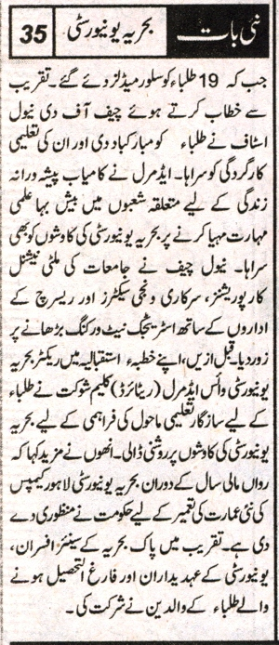

Bahria University Library Islamabad
Source: Nawai-I-Waqt, Sunday January 09, 2022

