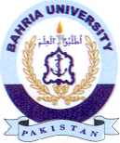
Bahria University Library Islamabad
Source: Pak Observer, Tuesday January 04, 2022

