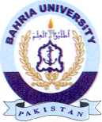
Bahria University Library Islamabad
Source: Dawn & Jang, Sunday January 02, 2022

