
Bahria University Library Islamabad
Source: Dunya, Saturday January 01, 2022

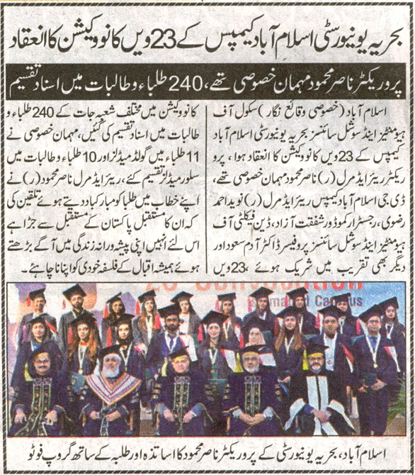

Bahria University Library Islamabad
Source: Nai Baat, Saturday January 01, 2022

