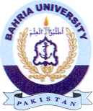
Bahria University Library Islamabad
Source: Dawn, Sunday December 26, 2021

