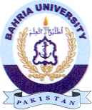
Bahria University Library Islamabad
Source: The News, Jang & Dunya Sunday December 05, 2021

