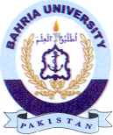
Bahria University Library Islamabad
Source: Express Sunday December 05, 2021

