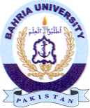
Bahria University Library Islamabad
Source: The News Sunday November 28, 2021

