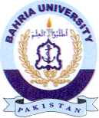
Bahria University Library Islamabad
Source: Nai Baat Friday November 26, 2021

