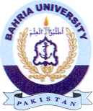
Bahria University Library Islamabad
Source: The News & Jang Sunday November 21, 2021

