
Bahria University Library Islamabad
Source: The Nation Wednesday November 10, 2021

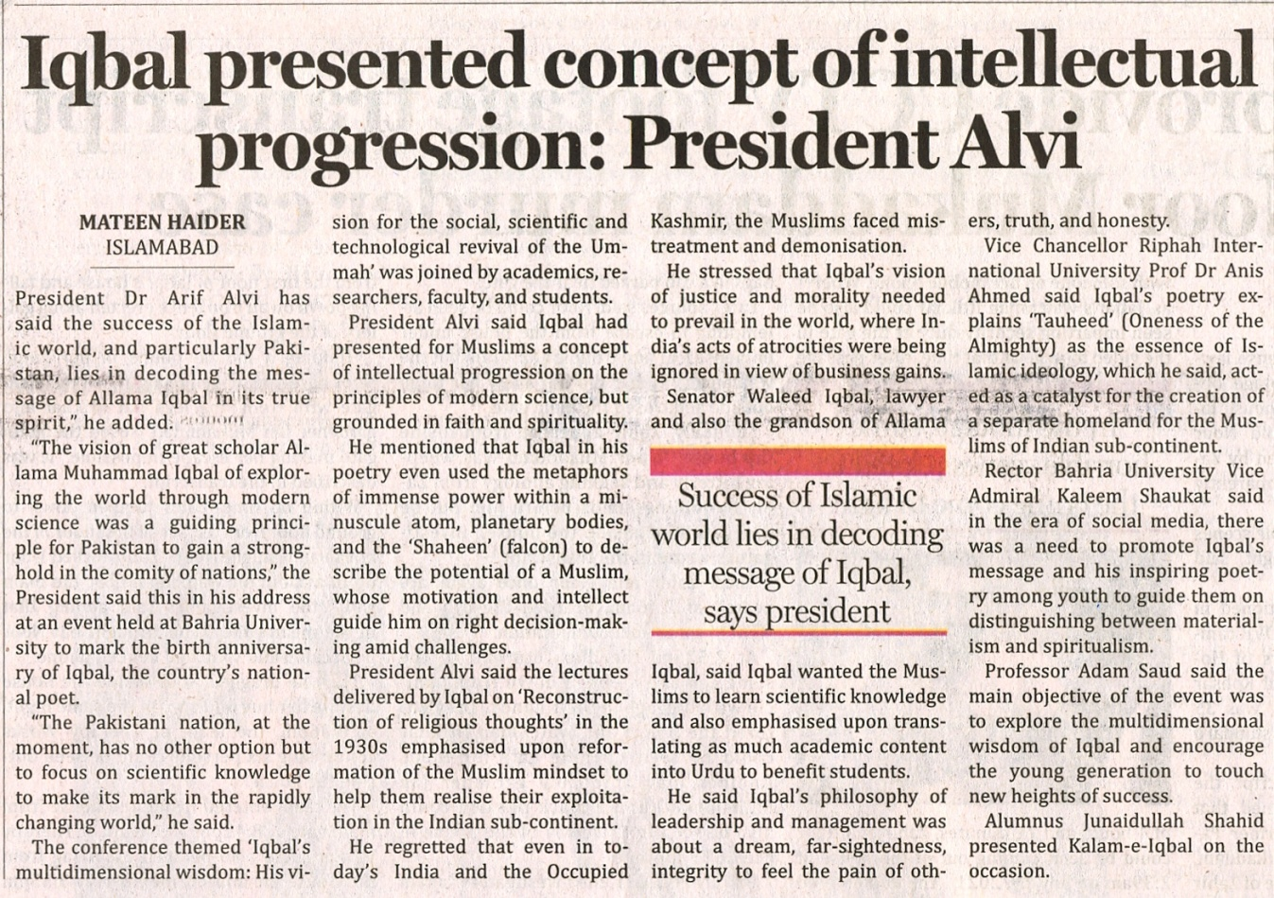

Bahria University Library Islamabad
Source: Pakistan Observer Wednesday November 10, 2021

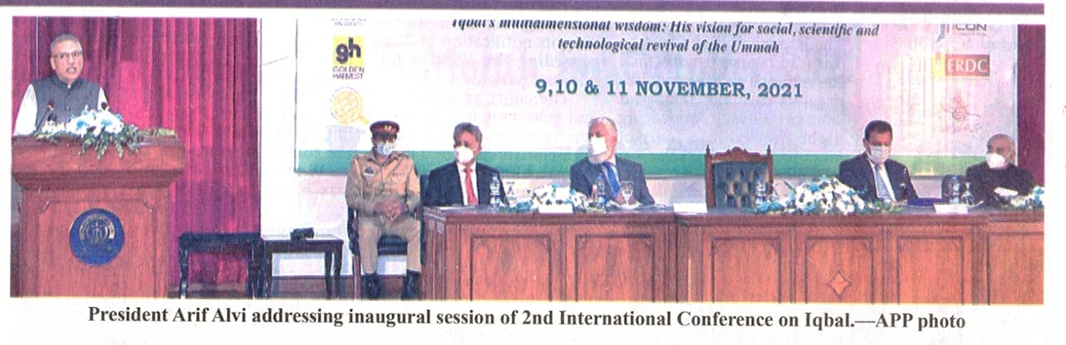

Bahria University Library Islamabad
Source: Nawa-i-Waqat Wednesday November 10, 2021

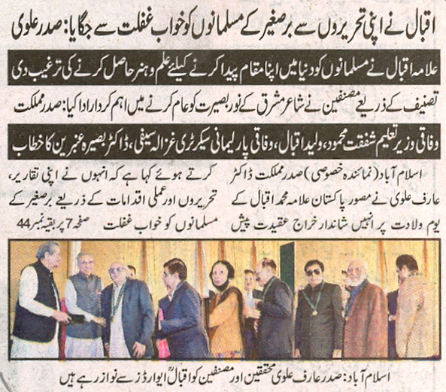

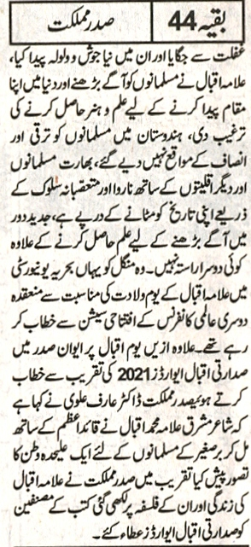

Bahria University Library Islamabad
Source: Dunya Wednesday November 10, 2021

