
Bahria University Library Islamabad
Source: Pakistan Observer Thursday November 04, 2021

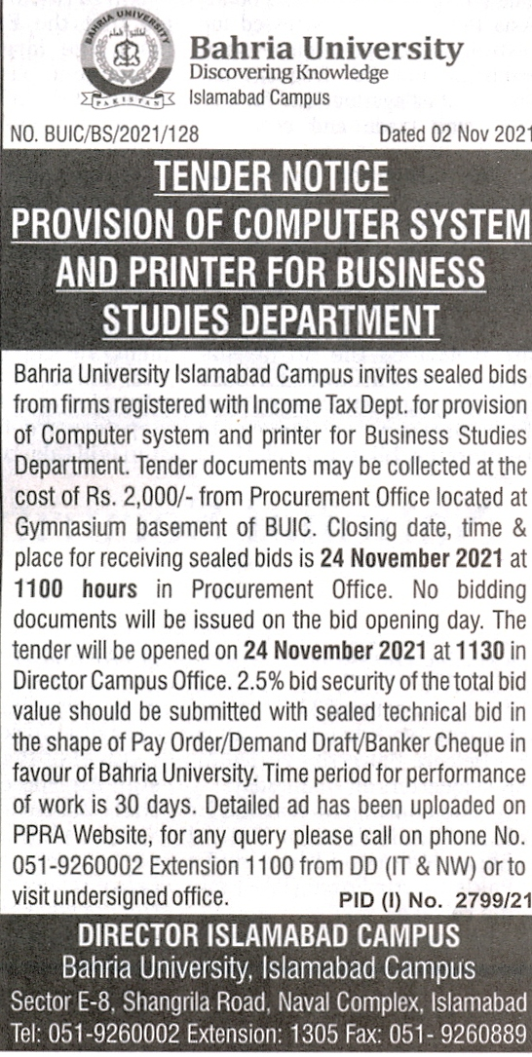

Bahria University Library Islamabad
Source: Daily 92 News Thursday November 04, 2021

