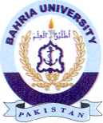
Bahria University Library Islamabad
Source: The News & Jang Tuesday November 02, 2021

