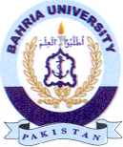

Bahria University Library Islamabad
Source: Pakistan Observer Thursday October 21, 2021

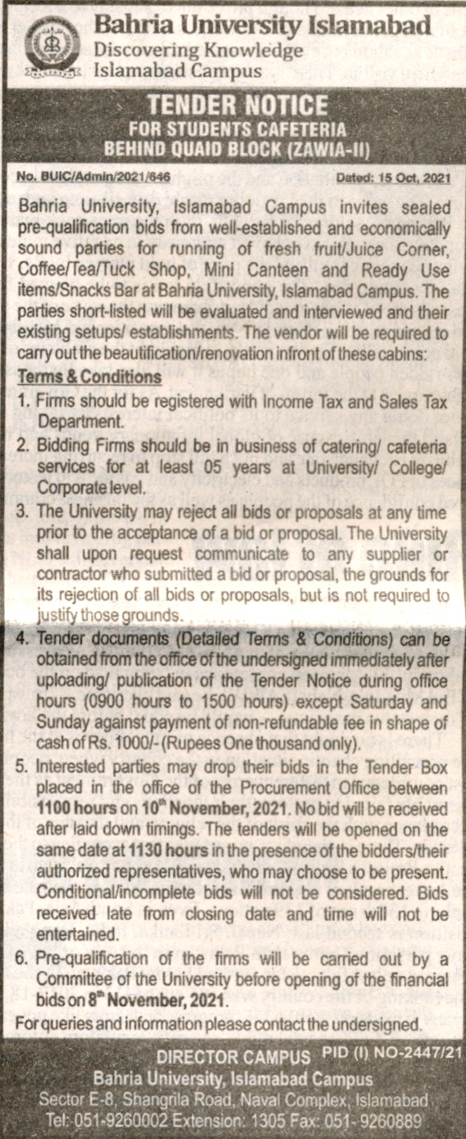

Bahria University Library Islamabad
Source: Nawa-i-Waqt Thursday October 21, 2021

