Health Care Monitoring System

Final Year Project
Supervised by
Engr. Shaftab Ahmed

Submitted by
Bushra Mushtaq Khan (01-233062-009)
Waqas Ahmad (01-233062-026)
BSCS

Department of Graduate Studies and Applied Sciences
Bahria University, Islamabad
Session 2006-2010
Acknowledgement

In the name of Allah the beneficent the merciful

We offer our sincerest gratitude to our supervisor, Engr. Shaftab Ahmed, who has supported us throughout our project with his patience and knowledge whilst allowing us the room to work in our own way. We attribute the level of our bachelor’s degree to his encouragement and effort and without him this project, too, would not have been completed. One simply could not wish for a better or friendlier supervisor.

Finally, we thank our parents for supporting us throughout all our studies at University.
CERTIFICATE

We accept the work contained in this report as a confirmation to the required standard for the partial fulfillment of the degree.

_________________ _________________ _________________
Engr. Shaftab Ahmed Internal Examiner External Examiner
Project Supervisor

______________________________
Head of Department (GS & AS)

In the name of Allah (SWT) the most beneficent and the most merciful.
Table of Contents
CHAPTER # 1 1
1.1 Introduction 2
1.2 Problem Description 2
1.3 Objective 3
1.3.1 Monitoring System 3
1.3.2 Alerts and Notification System 3
1.4 Scope 3
1.5 Project Phases 5
1.5.1 System design 5
1.5.2 Data base design 5
1.5.3 Development 6
1.5.4 Implementation 6
1.5.5 Testing 6
CHAPTER # 2 7
2.1 Target organization 8
2.2 Software Development Process Model 8
2.3 System Users 10
2.4 Role of Users in There panels in system 11
2.4.1 System Administrators 11
2.4.2 Receptionist 11
2.4.3 Nurse 12
2.4.4 Doctor 13
CHAPTER # 3 14
3.1 Patient Registration System 15
3.2 Patient Discharge 16
3.3 Patients Appointment management 16
3.4 Upcoming Medicine time management 17
3.5 Medical Therapy 17
3.6 Monitoring Panel 17
3.7 Intelligent agent management 17
3.8 Alarm system 18
3.9 History of patient 18
3.10 Administrator panel 18
3.11 Log of system 19
3.12 Printing facility 19
3.13 Common Functionalities 19
CHAPTER # 4 20
4.1 Unified Modeling Language 21
4.2 Use Case Diagram 21
4.2.1 Use case of Administrator 22
4.2.2 Use Case of Receptionist 23
4.2.3 Use case of Nurse 24
4.2.4 Use Case of Doctor 25
4.3 Deployment Diagram 26
4.4 Database Design 27
4.5 Data Flow Diagram 32
CHAPTER # 5 33
5.1 Visual Studio 8 34
5.2 Microsoft SQL Server 36
5.3 Microsoft Word for Data Flow and Diagrams 37
5.4 Microsoft Word 38
5.5 Adobe Photoshop 39
CHAPTER # 6 40
6.1 Test Cases 41
CHAPTER # 7 47
7.1 Starting the Application 48
7.2 Receptionist Panel 49
7.2.1 Register a patient 50
7.2.2 Patient Registered 51
7.2.3 Patient Registered printable report 52
7.2.4 Discharge a patient 53
7.2.5 Reception My Account 55
7.3 Nurse Panel 56
7.3.1 Appointments 57
7.3.2 Prescription 60
7.3.3 The Monitoring Panel 61
7.3.4 The Monitoring Panel (Monitoring Abnormality) 62
7.3.5 My Account 63
7.4 Administrator Panel 64
7.4.1 All Patients Report 65
7.4.2 All Doctors Report 66
7.4.3 Login Logout Report by Date 67
7.4.4 Full Login Logout Report 68
7.4.5 Create a new Account 69
7.4.5.1 Create a new Doctor Account 70
7.4.5.2 Create a new Nurse Account 71
7.4.5.3 Create a new Reception Account 72
7.4.6 Delete Account 73
CHAPTER # 8 76
CHAPTER # 9 82
9.1 Video Monitoring with Motion Detection 83
9.2 Account Details 83
9.3 More Sensors 83
9.4 Web based Software 83
9.5 Thesis of Dialysis Department 84
9.5.1 What is Dialysis 84
9.5.2 Working of dialysis Machine 84
9.5.3 The Dialysis Machine 85
9.5.4 Problem Description: 85
9.5.5 Doctor’s Requirements: 86
9.5.6 Problem Solution: 86
9.5.7 Demo Interface 87
References 88
Websites: 89
Research Papers: 90

CHAPTER # 1

Introduction

This chapter describes a brief introduction to our project.

Introduction

Health Care Monitoring System (HCMS) is the software to automate the monitoring system of hospital. It gives the way of patient’s care without visiting his/her bed. This is the software for hospital that can maintain the records based upon event based notification system. Intelligent agents are implemented in the software that makes the software more efficient.

Problem Description

There is traditional local area network setup in a hospital. All the beds in different wards have a physiological sensors attached to them. When a bed is occupied by a patient we will connect the sensors to the patient and these sensors will collect data like blood pressure, e.c.g, pulse rate, glucose, and temperature etcetera. There is an application installed on a doctor’s computer on which he can view all this data of any patient on his screen. This way the doctor is able to constantly monitor all his patients while sitting at the same spot and not having to move around. The application is also generating alarms and warnings to the doctors when some patient’s readings go above or below a certain level. This system keeps a statistical record of a patient's readings for later analysis. This system also provides the functionality to print reports.

With the help of this system we are able to enhance the efficiency of doctors without having them do any extra work instead doctors are at more ease.

Warning about a patients worrying situation will be generated at once and will come under notice at once instead of a doctor roaming around wards and nurses giving periodic check visits to patients.

History of a patients reading is available for a better analysis and as a proof in unfortunate or suspicious cases.

Objective

To create software for hospital, that collects physiological data of patient. This display is available to nurse and doctor. Doctor can also see patient registered to him from his panel.

Our basic motive was to automate the monitoring of Hospital in an efficient way and to provide accurate information to the doctors and nurses. The main features of our software are as follows:

Monitoring System

Our aim is to monitor the patients in the ward. We have developed a system that monitors the patients and displays the following parameters of each patient

- Live Video
- Blood Pressure
- Temperature
- Heart Rate

Alerts and Notification System

We have introduced intelligent agents, Alerts and Notification system in our project that monitor the patient’s health record in efficient way and responds to the users in the form of notifications and alarms.

Scope

This section tells you the scope of our project (HCMS). (HCMS) will require some studies in the field of medicine and medicine technology to understand how physiological sensors work and how to integrate them into our system. We have done a survey with doctors and medicine experts to find out what kind of data from patients they constantly need and the special cases for which they need special data or processed data.

(HCMS) monitor the patient’s physiological data remotely. There is central database on the server, where all the information like accounts information of the users and registration information of patient.

Users who connected are acting as a client and can access the database and use it for their purposes e.g doctor can see the history of patient where in history all the fields come from the data base.

Our system is divided into two developing parts. One part is the data acquisition in which we captured the live video through iConf SDK that is used in monitoring panel.

iConf create video conferencing applications easily, or add video/audio/text conferencing capabilities to the application, with this easy to use SDK for the .NET framework . This SDK will prove to be our solution to all issues related to developing a comprehensive video application using Visual Studio.NET. [1]

Video encoding/decoding is done using iConf’slicensed H.263/H.264 codecs which are built into the SDK. Audio conferencing uses the SPEEX codec. To facilitate communication behind NATs and firewalls, the iConf .NET SDK is bundled with the Central Server .NET Windows Service that acts as a directory service for the iConf Client/Server .NET components.[1]

The Central Server is necessary when communication needs to occur between parties that have private IP addresses internal to a local area network that are inaccessible to the outside world, or that have ports blocked by a firewall.[1]

Here are some key features of "iConf.NET SDK":

- Each iConf Server .NET component can stream video, audio, text data to multiple clients
- Support for DirectX compatible video capture devices and webcams
- Adjustable H.263 and H.264 parameters
- Configurable communication ports
- Support for connection monitoring and more [1]

Other part is software, which have the following features

- Intelligent Agents
- History
- Event Notification
- Web based Panel for doctor, Nurse, Receptionist and Administrator
- Centralized data base
- Saving record for each patient
- Live video of patient
- Alarms
- Medical Therapy(medicine prescription ,daily dosage)
- Reports
- Logs
- Printing facility

Through this software we are able to view data of one or more patient in monitoring panel.

Project Phases
There are following phases of our project

System design on the basis of analysis

1st off all we made consistent and user friendly design of system. Also describe all software required to support the system for database, operating systems.

Data base design

Tables are designed for our system and relationships are defined, which describe in detail the system’s communications network, i.e. how system components are linked.

Development

We have developed user friendly interface and back end functionality in .Net C#. For data base we used SQL to store data and we have installed data base on server so every user can access the data base.

Crystal Reports is used for reporting purpose.

Implementation

We have installed our data base on server and client on two separate computers

Testing

Before implementation we have tested our software by integration testing and unit testing. After implementation we have performed black box and white box testing on our software.

CHAPTER # 2

SYSTEM OVERVIEW

This chapter provides an overview of Health care monitoring system development.

Target organization

Our system is not developed for any specific hospital. It can be used by any hospital for remote monitoring of patient.

System design is expandable because we developed it as a network system. This allowed the monitoring and the management services to be available remotely.

Software Development Process Model

“A software development process is a structure imposed on the development of a software product. Synonyms include software life cycle and software process. There are several models for such processes, each describing approaches to a variety of tasks or activities that take place during the process.”[2]

The software process model that we have chosen to develop our system is the spiral model. A standard definition of the spiral process model and the steps involved in spiral process model are addressed in the following two paragraphs.

“The spiral model is a software development process combining elements of both design and prototyping-in-stages, in an effort to combine advantages of top-down and bottom-up concepts. Also known as the spiral lifecycle model (or spiral development), it is a systems development method (SDM) used in information technology (IT). This model of development combines the features of the prototyping model and the waterfall model. The spiral model is intended for large, expensive and complicated projects.”[2]

The steps in the spiral model iteration can be generalized as follows:

The new system requirements are defined in as much detail as possible. This usually involves interviewing a number of users representing all the external or internal users and other aspects of the existing system. [2]

A preliminary design is created for the new system. This phase is the most important part of "Spiral Model". In this phase all possible (and available) alternatives, which can help in developing a cost effective project are analyzed and strategies are decided to use them. This phase has been added specially in order to identify and resolve all the possible risks in the project development. If risks indicate any kind of uncertainty in requirements, prototyping may be used to proceed with the available data and find out possible solution in order to deal with the potential changes in the requirements. [2]

A first prototype of the new system is constructed from the preliminary design. This is usually a scaled-down system, and represents an approximation of the characteristics of the final product. [2]

A second prototype is evolved by a fourfold procedure:

- Evaluating the first prototype in terms of its strengths, weaknesses, and risks.
- Defining the requirements of the second prototype.
- Planning and designing the second prototype.
- Constructing and testing the second prototype.[2]
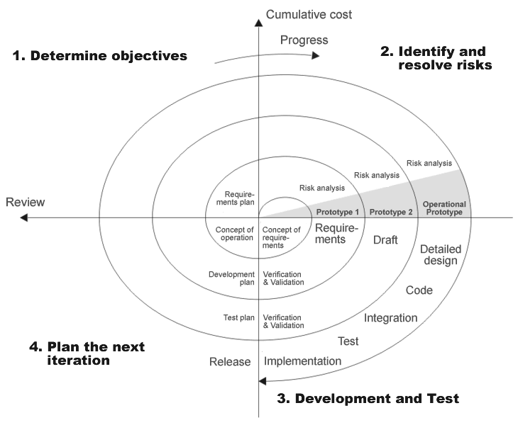
FIG: 2.3.1 - A Representation of Spiral Process Model[2]

For Development spiral model best suits our project.

    - To develop the system first off all we made consistent and user friendly design of system. Then we have made the basic interface of the system on the basis of that.

    - After that we have designed the database and implemented it with the basic design of our system and checked database working with that basic design.

    - Basic interface collect the stored readings from the database and display them on the screen then we developed the real interface on the basis of that then we added tables and defined relationships in the data base.

    - At every stage of updation of data base we tested the system for proper working.

We worked on the basis of spiral model tips of designing, implementation, testing, reviewing and then again designing until it full fill all the requirements.

From above points it is clearly seen that the spiral process model is very suitable for our system because the system is a mesh of databases, user friendly interfaces, real time services and network programming. If we selected other process model, then system can be build but the system could become complicated.

So due to this we have selected spiral spinning in all the phases like design, development and testing processes. Our system design is very simple and easy to understand by any person.

System Users

Users who are involved in using system are given in the following.

- System Administrators
- Receptionists
- Nurses
- Doctors

All of these users have some functionality to perform.

Role of Users in There panels in system

System Administrators

System Administrator is the prime user of the system. One of the main responsibilities of the system Administrator is to create accounts of doctors, nurses and receptionists. By that they all can access system with their login user name and password. All of this is just for authentication.

The system Administrator can also delete the accounts of doctor, nurse and receptionist by selecting user id. The Administrator can change and update the data base.

The Administrator can view the daily log which shows that how many users are sign in and sign out with time and date.

Administrator can also see the patients admitted in hospital and available doctors.

So all back end handling of system is managed by Administrator.

Receptionist

In hospital patients who come to hospital for admission, first he/she is received by receptionist. Receptionist can register patient on the basis of online doctors and bed vacant displayed to him in his panel. After registration patient will be admitted.

He/she can also discharge patient by entering user id, but before patient discharge, system will ask for entering the pin code assign to receptionist for authentication.

If he/she will not enter the correct code so system will deny discharging the patient.

He/she can also change his password from his/her panel.

Nurse

The next user is the nurse. A nurse is allowed to appoint the patient to online doctor who is registered by receptionist from reception panel. Nurse also sees the upcoming medicine times of patient from her panel then she can view the prescription detail available and she asks another nurse to visit the patient and give him/her medicine.

Upcoming medicine times are prompted according to the schedule of the patient’s dosage which is scheduled for morning, noon, and evening.

She check the monitoring panel from where she can see patient’s live video and health record coming from ward. There is blood pressure, temperature and pulse rate in health record.

Intelligent agent is added that is periodically checking the recent data of all the patients and Display the patient’s Health status. It also generates alarms in the form of message in any emergency of the patient.

There is an option of bed in nurse panel from where she can see the condition of patient in the way

        - if color of bed is blinking in red and green it means there is critical condition of patient on that bed

        - if color of bed is blinking in blue and green it means patient needs medicines

        - if color of bed is green it means everything is all right with the patient

She can also change her password from her panel.

Doctor

The doctor is the last user of our software. Doctor has the services in his panel that tells the doctor about upcoming appointments appointed by the nurse. In this way the doctor is able to manage his appointments.

Doctor can see the patient’s detail by seeing his history. He can also see the live video and health record of his patient. And doctor is also be able to perform general functions like change password.

CHAPTER # 3

Requirement Analysis

Our basic requirement was to monitor a patient in the ward. To achieve this motive we have to go through from the following steps.

Patient Registration System

Patient must be registered first for admission in ward. For this purpose we must registered the patient.

First we will discuss why it is necessary to keep record of the patients admitted to the ward?

Physiological readings of patient coming from the monitoring panel will display so It is a very important that the readings must point to a particular patient. For that purpose some of the information of the patient must be coming in the monitoring panel from his registration e.g patient name, age, gender etc because it is difficult for the doctor, nurse or any other staff member to remember all the time that which bed is assigned to which patient.

So it is important that the bed number assigned to the patient will have to be fed into the system.

The information that the registration system will be keeping includes

- Admission date
- Patient name
- Mother name
- Age
- Gender
- Address
- NIC
- Phone no
- Marital status
- Name of next of kin
- Phone of next of kin
- Medical history
- Present disease
- Injuries/ surgeries
- Blood pressure
- Temperature
- Weight
- Height
- Bed Allocated
- Doctor Assign
- Any other medical condition

Some other question must be filled by the patient in registration form whose answer will be in the form of “Yes” or “No”, which are

- Do you Drink alcohol
- Do you smoke
- Fever
- Runny nose
- Chronic cough
- Dry throat
- Asthma
- Heart pain
- High blood pressure
- Low blood pressure
- Diarrhea
- Constipation
- Joint/ muscle pain
- Anemia
- Bleeding problem

Patient Discharge

After treatment completion when patient will be discharged, there must be a mechanism in system to discharge a patient by entering patient id.

Patients Appointment management

After patient registration, patient must be appointed to doctor on the basis of availability of doctor.

This automated appointment system will facilitate the doctors in their daily work. That system will give an interface to doctor to see all upcoming appointments in which he/she can see the patient id with time of appointment. By keeping track of all the upcoming appointments, doctor can easily manage the time for appointment.

So there must be a system of patient appointments.

Upcoming Medicine time management

There must be system for Nurse to the upcoming medicine times of patient from her available system interface so for that she must have the prescription detail available on the interface given to nurse.

Upcoming medicine times notification management (Medical Therapy)

Upcoming medicine must be prompted to nurse according to the schedule of the patient’s dosage which will be scheduled for morning, noon, evening and night.

Monitoring Panel

There must be a monitoring panel for nurse from where she can see patient’s live video and health record coming from ward. Through that nurse can see the abnormality from monitoring panel.

Intelligent agent management

Intelligent agent must be added that will periodically check the recent data of all the patients coming from ward and display normality or abnormality of the patient’s Health
Health record consist of
  - Pulse rate
  - Blood pressure
  - Temperature

Alarm system

System must generate alarms after the intelligent agent give notification of any kind of abnormality of the patient’s health, checked by intelligent agent.

History of patient

System must allow the doctor to see the patient’s detail by seeing his history.

History must consist of

- Patient name
- Age
- Gender
- Bed allotted
- Phone number
- Weight
- Height
- Blood Pressure
- Temperature
- Previous disease
- Present disease
- Previous Injuries/Surgeries
- Other medical condition

Doctor must know about that patient is alcoholic or smoker.

With the history doctor must also see the live video and health record of his patient.

Administrator panel

There must be a system Administrator from where Administrator can create account of doctors, nurses and receptionists for their access to the system with their login user name and password.

User name and password must be implemented for authentication purposes.

The system Administrator can only delete the doctor, nurse and receptionist account.

Log of system

The Administrator must view the daily log which will show that how many users are sign in and sign out with time and date.

Administrator can also see the report of patients admitted in hospital and available doctors.

Printing facility

Printing facility must be provided.

Common Functionalities

All users can change their passwords from their own end.

CHAPTER # 4

System Design

This chapter describes the actual flow of data of our overall system in graphical form.

Unified Modeling Language

Unified Modeling Language (UML) is a standardized general-purpose modeling language in the field of software engineering.

UML includes a set of graphical notation techniques to create visual models of software-intensive systems. [5]

Diagram that is necessary to understand our systems is

Use Case Diagram

“A use case diagram in the Unified Modeling Language (UML) is a type of behavioral diagram defined by and created from a Use-case analysis. Its purpose is to present a graphical overview of the functionality provided by a system in terms of actors, their goals (represented as use cases), and any dependencies between those use cases.The main purpose of a use case diagram is to show what system functions are performed for which actor. Roles of the actors in the system can be depicted.” [6]

The following are the use cases of our system are

- Use case of Administrator

- Use Case of Receptionist

- Use case of Nurse

- Use Case of Doctor

Use case of Administrator

Create users

Delete users

Administrator
Logs and Reports

Login and logout Reports

View online doctors

View admitted Patients

Use Case of Receptionist

Registered Patient

Discharge Patient

Patient Health Report Management
Receptionist

Personal Account Settings

Use case of Nurse

View new patients to be appointed

See Medical Therapy
Acknowledge Abnormality
Monitor Pulse Rate Reading
Monitor Blood Pressure Reading
Monitor Temperature Reading

Monitor Live Video of Patients of Each Bed
Monitoring panel

Personal Account Settings

View Upcoming Medicines Time

Patient Appoint

Nurse

Use Case of Doctor

Receive New Appointments

See Live Video of His Patients

Edit Prescription of His Patient
Give Prescription to His Patients

See Live Temperature Reading of His Patient

See Live Blood Pressure Reading

Personal Account Setting

See History of His Own Patients

See Live Pulse Rate Reading of His Patient

Doctor

Deployment Diagram

We have deployed our system by the following sequence shown in diagram

LAN/Wireless LAN
Switch
Switch
Server for SQL

Bed1
Bed2
n Bed
Bed3
Admin’s Terminal
Reception’s Terminal
Nurse’s Terminal
….
Doctor’s Terminal

Database Design

The schema of the tables of the database is given below.
Table Name: Administrator
Attribute Name | Data Type | Nulls Allowed | Key
a_id | varchar(15) | No | PK
a_name | varchar(10) | No | -
a_pass | varchar(50) | No | -
a_address | varchar(MAX) | No | -
a_phone | nchar(15) | No | -
a_sex | varchar(10) | No | -
a_age | nchar(15) | No | -
Table Name: reception
Attribute Name | Data Type | Nulls Allowed | Key
r_id | varchar(30) | No | PK
r_name | varchar(30) | No | -
r_pass | varchar(20) | No | -
r_pincode | varchar(20) | No | -
r_address | varchar(MAX) | No | -
r_phone | varchar(50) | No | -
r_age | varchar(3) | No | -
r_sex | varchar(6) | No | -
r_datereg | varchar(MAX) | No | -
r_nic | varchar(20) | Yes | -
Table Name: Nurse
Attribute Name | Data Type | Nulls Allowed | Key
n_id | varchar(10) | No | PK
n_name | varchar(50) | No | -
n_pass | varchar(10) | No | -
n_pin | varchar(50) | No | -
n_address | varchar(MAX) | No | -
n_phone | varchar(50) | No | -
n_age | varchar(3) | No | -
n_sex | varchar(6) | No | -
n_regdate | varchar(MAX) | No | -
n_nic | varchar(20) | No | -
n_status | varchar(10) | No | -

Table Name: doctor
Attribute Name | Data Type | Nulls Allowed | Key
d_id | varchar(10) | No | PK
d_name | varchar(50) | No | -
d_pass | varchar(10) | No | -
d_address | varchar(MAX) | No | -
d_phone | nchar(15) | No | -
d_age | varchar(3) | No | -
d_sex | varchar(6) | No | -
d_regdate | varchar(MAX) | No | -
d_nic | varchar(20) | No | -
d_status | varchar(10) | No | -
d_expertise | varchar(MAX) | No

Table Name: patient

Attribute Name | Data Type | Nulls Allowed | Key
p_id | varchar(10) | No | PK
p_name | varchar(50) | No | -
p_pass | varchar(10) | No | -
p_address | varchar(MAX) | No | -
p_phone | nchar(15) | No | -
p_age | varchar(3) | No | -
p_sex | varchar(6) | No | -
p_regdate | varchar(MAX) | No | -
p_nic | varchar(20) | Yes | -
p_nok | varchar(10) | No | -
d_nokphone | nchar(15) | No

p_nokphone | nchar(15) |  | Key
p_disease | varchar(MAX) | No
p_nic | nchar(15) | Yes
p_bedid | nchar(2) | No
p_docid | varchar(25) | No
p_date_addmission | varchar(40) | No
p_date_discharge | varchar(40) | Yes
p_med_history | varchar(MAX) | Yes
p_injur_sur | varchar(MAX) | Yes
p_alcoholic | varchar(5) | No
p_smoker | varchar(5) | No
p_alergy_hayfever | varchar(5) | No
p_runny_nose | varchar(5) | No
p_chronic_cough | varchar(5) | No
p_dry_throat | varchar(5) | No
p_asthma | varchar(5) | No
p_heart_pain | varchar(5) | No
p_h_bp | varchar(5) | No
p_l_bp | varchar(5) | No
p_diarrhea | varchar(5) | No
p_constipation | varchar(5) | No
p_joint_muscle_pain | varchar(5) | No
p_anemia | varchar(5) | No
p_bleeding_problems | varchar(5) | No
p_any_other_med_condition | varchar(MAX) | Yes
p_admitstatus | varchar(20) | Yes
med1 | varchar(MAX) | Yes
med2 | varchar(MAX) | Yes
med3 | varchar(MAX) | Yes
med4 | varchar(MAX) | Yes
med5 | varchar(MAX) | Yes
med6 | varchar(MAX) | Yes
med7 | varchar(MAX) | Yes
med8 | varchar(MAX) | Yes
med9 | varchar(MAX) | Yes
med10 | varchar(MAX) | Yes
medtime1 | int | Yes
medtime2 | int | Yes
medtime3 | int | Yes
medtime4 | int | Yes
medtime5 | int | Yes
medtime6 | int | Yes
medtime7 | int | Yes
medtime8 | int | Yes
medtime9 | int | Yes
medtime10 | int | Yes
p_temp | varchar(10) | No
p_height | varchar(10) | No
p_weight | varchar(10) | No
p_bp | varchar(50) | No
p_appoint_status | varchar(50) | Yes
med1status | varchar(10) | Yes
med2status | varchar(10) | Yes
med3status | varchar(10) | Yes
med4status | varchar(10) | Yes
med5status | varchar(10) | Yes
med6status | varchar(10) | Yes
med7status | varchar(10) | Yes
med8status | varchar(10) | Yes
med9status | varchar(10) | Yes
med10status | varchar(10) | Yes
Meddate | varchar(50) | Yes
p_nokphone | nchar(15) | No
p_disease | varchar(MAX) | No
p_nic | nchar(15) | Yes
p_bedid | nchar(2) | No
p_docid | varchar(25) | No
p_date_addmission | varchar(40) | No
p_date_discharge | varchar(40) | Yes
p_med_history | varchar(MAX) | Yes
p_injur_sur | varchar(MAX) | Yes
p_alcoholic | varchar(5) | No
p_smoker | varchar(5) | No
p_alergy_hayfever | varchar(5) | No

Table Name: action
Attribute Name | Data Type | Nulls Allowed | Key
a_id | int | No | PK
p_id | varchar(50) | No | -
d_id | varchar(50) | No | -
d_name | varchar(50) | No | -
p_name | varchar(50) | No | -
a_date | varchar(50) | No | -
a_status | varchar(50) | No | -
a_time | varchar(50) | No | -
a_check | varchar(50) | No | -
a_add_pin | varchar(50) | No

Table Name: appointments
Attribute Name | Data Type | Nulls Allowed | Key
a_id | int | No | PK
p_id | Varchar(20) | No
d_id | Int | No
d_name | int | No
p_name | Varchar(13) | No
a_date | Datetime | No
a_status | char(1) | No
a_time | Int | No
a_check | datetime | No
a_add_pin | varchar(50) | No
Table Name: logdetail
Attribute Name | Data Type | Nulls Allowed | Key
Srno | int | No | PK
Logname | varchar(50) | No
Logdate | varchar(50) | No
Logtime | varchar(50) | No
Lodges | varchar(50) | No
Logstatus | varchar(50) | No
Table Name:bed (Tables of all beds are same as given below)
Attribute Name | Data Type | Nulls Allowed | Key
Id | int | No | PK
pulse_rate | int | No
Temp | int | No
Bpupper | int | No
Bplower | int | No

Data Flow Diagram
The data flow diagram of overall system is given below
Personal Account
Setting
Patient Health Report Management
Management
Appoint Patient
Admin
Discharge
Receptionist
Nurse
Doctor
Patient
Monitoring Panel
View upcoming
Medicine Times
Registration
Personal Account
Setting
See Medical Therapy
Acknowledge Abnormality
Monitor Pulse Rate Reading
Monitor Blood Pressure Reading
Monitor Temperature Reading

Monitor Live Video of Patients of Each Bed
Receive New Appointments

Give Prescription to His Patients

Edit Prescription of His Patient

See Live Video of His Patients

See Live TemperatureReading of His Patient

See Live Pulse RateReading of His Patient

See Live Blood PressureReading of His Patient

See History of His Patients

Personal Account Setting

Create User
Logs
Delete User

CHAPTER # 5

Tools and Technologies
In this chapter explains the tools and technologies that have used in development of our system.

Visual Studio 8

The Microsoft .NET Framework is a software framework that can be installed on computers running Microsoft Windows operating systems. It includes a large library of coded solutions to common programming problems and a common language infrastructure that manages the execution of programs written specifically for the framework. The .NET Framework supports multiple programming languages in a manner that allows language interoperability, whereby each language can utilize code written in other languages; in particular, the .NET library is available to all the programming languages that .NET encompasses.

The framework's Base Class Library provides a large range of features including user interface, data access, database connectivity, cryptography,web application development, numeric algorithms, and network communications. The class library is used by programmers, who combine it with their own code to produce applications.

Programs written for the .NET Framework execute in a software environment that manages the program's runtime requirements. Also part of the .NET Framework, this runtime environment is known as the Common Language Runtime (CLR). The CLR provides the appearance of anapplication virtual machine so that programmers need not consider the capabilities of the specific CPU that will execute the program. The CLR also provides other important services such as security, memory management, and exception handling. The class library and the CLR together constitute the .NET Framework. [3]

For interface of our project we used visual studio 8. The front end is made in Visual C#. The system is compiled using Microsoft IDE Visual Studio 8. Visual studio 8 implements .NET 3.5, that’s why system required .NET Framework 3.5 which support on a machine to run.

Basically we chose Microsoft Visual Studio because it provides an easy designing interface which saves much time in development as compared to C++, JAVA or any other language.
Figure # 5.1.1 illustrates Environment of Visual Studio 8.

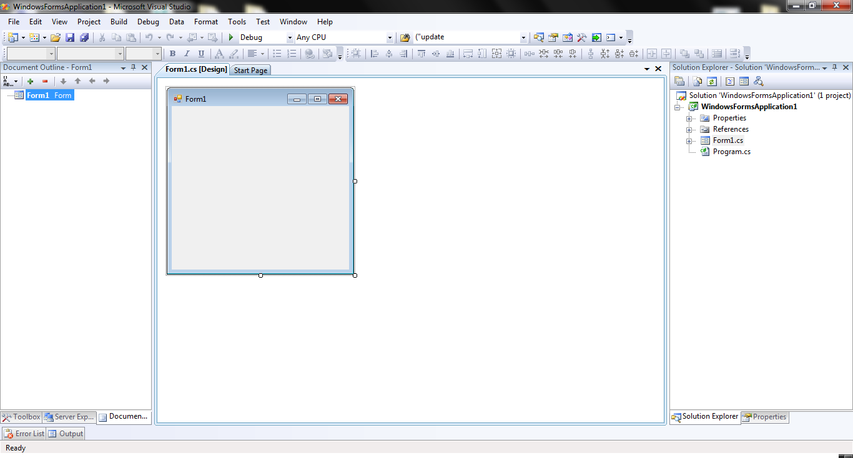
Fig 5.1.1Environment of Visual Studio 8

Microsoft SQL Server

For relational database management system we chose Microsoft SQL Server Management studio Express Edition 2005.

SQL Server Management Studio is a tool included with Microsoft SQL Server 2005 and later versions for configuring, managing, and Administering all components within Microsoft SQL Server. The tool includes both script editors and graphical tools which work with objects and features of the server.[4]

A central feature of SQL Server Management Studio is the Object Explorer, which allows the user to browse, select, and act upon any of the objects within the server.[4]

Microsoft has also introduced a graphical configuration tool called SQL Server Management Studio Express (SSMSE) for SQL Server Express.[4]

As with all of Microsoft's "Express" products, this is downloadable as a standalone tool or integrated with a SQL Server Express edition at no charge. The tool's limitations lie in the fact that it cannot manage SQL Server Analysis Services, Integration Services, Notification Services, Reporting Services, or SQL Server 2005 Mobile Edition.[4]

SQL management studio is the principal database Administration portal for Microsoft SQL databases and many database Administrators spend a large percentage of time in the software to perform their job responsibilities. [4]


Fig 5.2.1 : Microsoft SQL Server

Microsoft Word for Data Flow and Diagrams

Another tool Microsoft word is used for all the data flow diagrams, database design and the entity relationship diagrams.

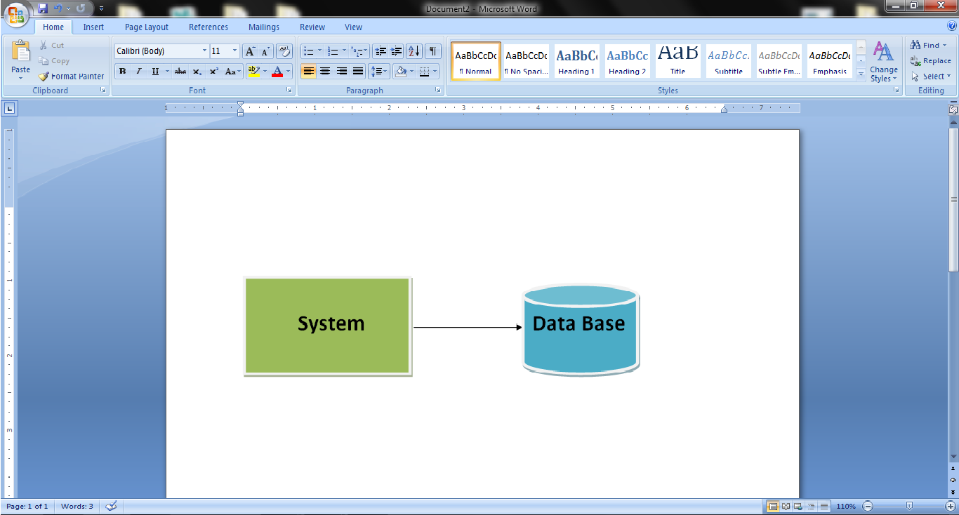

Fig 5.3.1 – Microsoft Word

Microsoft Word

For documentation, we used Microsoft word.
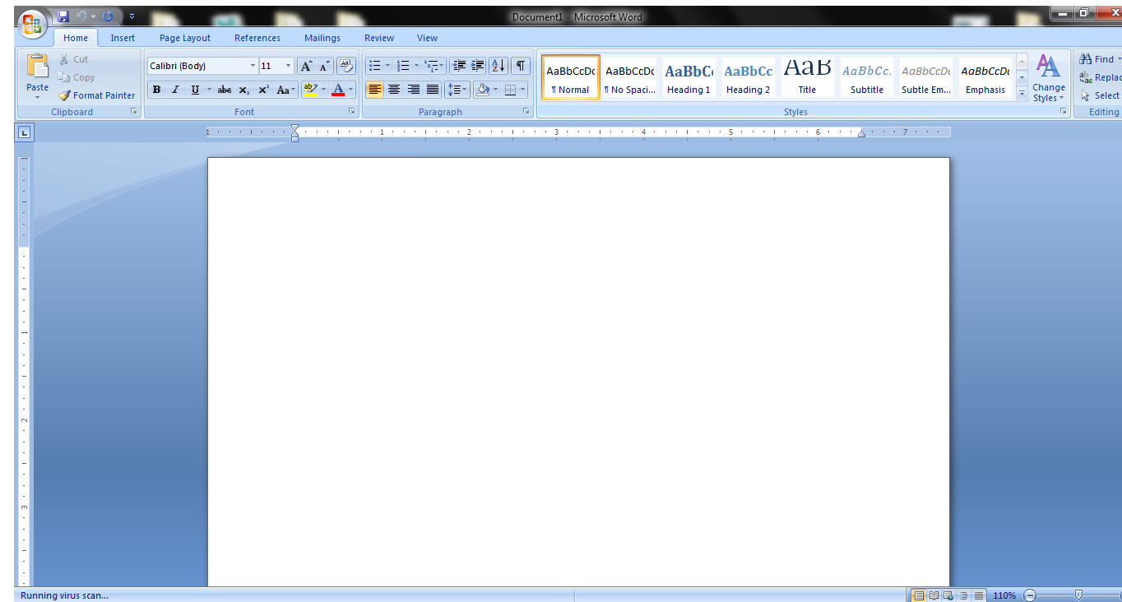

Fig 5.4.1 Microsoft Office Word

Adobe Photoshop

We used Adobe Photoshop 7.0 for the making images and icons that we used for designing of interface of our system.



Fig 5.5 Adobe Photoshop 7.0

CHAPTER # 6

SYSTEM TESTING

Test Cases

In this chapter we have tested our software by the unit and integration testing method at the time of development. Errors were found and removed at the time of development. After development we have tested our software by black and white box testing methods and found the following results

We have recorded the testing results in the following table: -

Sr. No | Form Name | Action Performed | Expected Result | Observed Result | Remarks
1 | Login | Login without username password | Unable to login error message will be populated | Error message is shown, unable to login | Ok
2 | Login | Login with wrong password | Message will be populated that wrong username or password | Error message displayed | Ok
3 | Login | Login with wrong username | Message will be populated that wrong username or password | Error message displayed | Ok
4 | Login | Login with wrong designation | Message will be populated that wrong username or password | Error message displayed | Ok
5 | Login | Login with correct receptionist account | Reception form should displayed | Receptionist form displayed | Ok
6 | Login | Login with correct doctor account | Doctor form should displayed | Doctor form displayed | Ok

7 | Login | Login with correct Nurse account | Nurse form should displayed | Nurse form displayed | Ok
8 | Login | Login with correct Administrator account | Administrator form should displayed | Administrator form displayed | Ok
9 | Login | Reset button pressed | Fields should be cleared | Fields were cleared | Ok
10 | Login | Exit button pressed | Application will be closed | Application was closed | Ok
11 | Login | X button pressed | Application will be closed | Application was closed | Ok
12 | Administrator | View logs and reports | Log view should display | Log view displayed | Ok
13 | Administrator | View all patient report | Report should display | Report displayed | Ok
14 | Administrator | Print all patient report | Report should print | Report printed | Ok
15 | Administrator | View all doctor report | Report should display | Report displayed | Ok
16 | Administrator | Print all doctor report | Report should print | Report printed | Ok
17 | Administrator | View full log report | Report should display | Report displayed | Ok
18 | Administrator | Print full log report | Report should print | Report printed | Ok
19 | Administrator | View daily log report by date | Report should display | Report displayed | Ok

20 | Administrator | Print daily log report by date | Report should print | Report printed | Ok
21 | Administrator | Create a Doctor account | Account should be created | Account created successfully | Ok
22 | Administrator | Create a Nurse account | Account should be created | Account created successfully | Ok
23 | Administrator | Create a Receptionist account | Account should be created | Account created successfully | Ok
24 | Administrator | Delete a doctor account | Account should be deleted | Account deleted successfully | Ok
25 | Administrator | Delete a Nurse account | Account should be deleted | Account deleted successfully | Ok
26 | Administrator | Delete a Receptionist account | Account should be deleted | Account deleted successfully | Ok
27 | Receptionist | Register a patient | Patient registered ID create and should display | Patient registered and ID displayed | Ok
28 | Receptionist | Print patient’s record | Should print the report | Printed successfully | Ok
29 | Receptionist | Discharge a patient | Patient should discharge | Patient discharged | Ok
30 | Receptionist | Refresh button pressed | Online doctors, nurses and beds vacant should be refreshed and displayed | Refreshed and displayed | Ok

31 | Receptionist | Logout button pressed | Message displayed “Do you want to log out YES/NO” | Message displayed | Ok
32 | Receptionist | Yes button pressed on logout message | Logout and display main form | Logout successfully and main form displayed | Ok
33 | Receptionist | No button pressed on logout message | Control should returned to the reception form | Control returned | Ok
34 | Receptionist | Change his/her password | Change password upon entering the correct pin code | Password changed on correct pin code input | Ok
35 | Nurse | Appoint a patient | Should appoint the patient successfully | Patient appointed successfully | ok
36 | Nurse | Appoint same patient again | Display message “Patient already appointed” | Message displayed | ok
37 | Nurse | View the prescription | Can view the medicine of any patient upon entering ID | Medicines displayed upon entering ID | ok
38 | Nurse | Monitoring Panel View | View monitoring panel | Monitoring panel viewed | ok
39 | Nurse, Monitoring panel | Monitor the patients | Monitor successfully | Monitoring patients successfully | ok

40 | Nurse, Monitoring panel | Handle abnormality | Should acknowledge the abnormality | Abnormality acknowledged | Ok
41 | Nurse, Monitoring panel | View prescription | View the prescription of specific id | Prescription viewed | Ok
42 | Nurse, Monitoring panel | View live video | Video viewed upon each bed click | Displayed the video of particular bed upon click | ok
43 | Nurse, Monitoring panel | View live reading | Live readings should be displayed | Displayed the reading of specific patient who is selected | Ok
44 | Nurse | Change his/her password | Change password upon entering the correct pin code | Password changed on correct pin code input | Ok
45 | Nurse | Refresh button pressed | Medicine time and patients to be appointed should refreshed | Refreshed and displayed | Ok
46 | Nurse | Logout button pressed | Message displayed “Do you want to log out YES/NO” | Message displayed | Ok
47 | Nurse | Yes button pressed on logout message | Logout and display main form | Logout successfully and main form displayed | Ok
48 | Nurse | No button pressed on logout message | Control should returned to the nurse form | Control returned | Ok

49 | Doctor | View his/her patients | Should view his/her patients | Patients displayed | Ok
50 | Doctor | View his/her appointments | Should view his/her appointments | Appointments displayed | Ok
51 | Doctor | View medical emergency | Should view emergency | Emergency viewed | Errors were found but rectified Ok
52 | Doctor | View his/her patient’s prescription | Should view his/her patient’s prescription | Patient’s prescription displayed | Ok
53 | Doctor | View his/her patient’s history | Should view his/her patient’s history | Patient’s history displayed | Ok
54 | Doctor | View his/her patient’s live data | Should view his/her patient’s live data | Patient’s live data displayed | Ok
55 | Doctor | View his/her patient’s live video | Should view his/her patient’s live video | Patient’s live video displayed | Ok
56 | Doctor | Edit his/her patient’s prescription | Should edit his/her patient’s prescription | Patient’s prescription edited | Ok
57 | Doctor | Change his/her password | Change password upon entering the correct pin code | Password changed on correct pin code input | Ok
58 | Main Form | Log in with same account on 2 PCs | One should display message “Already Logged in” | Message displayed | Ok

CHAPTER # 7

USER MANUAL

This chapter covers the user manual of our software. It will introduce the user interfaces to the users.

Starting the Application

After starting the application, the user will see the following screen,.


In this screen you have to enter the user name, password and our designation to login. Only authorized persons are allowed to login. If somebody tries to login he/she will see the following screen
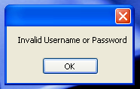

Receptionist Panel

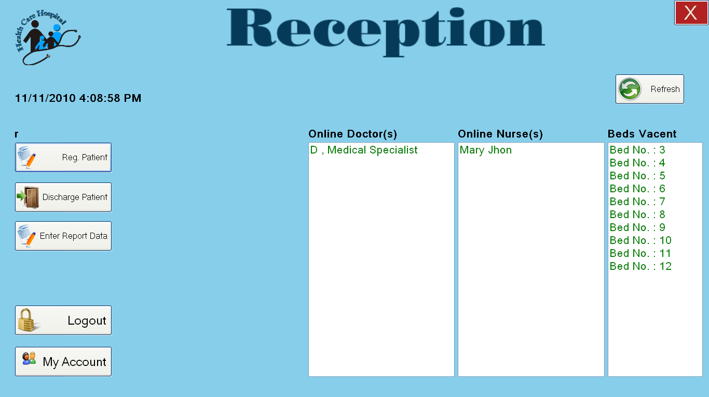

After the login by reception, he/she will see the above screen.

Receptionist can do the following activities: -
- View the beds vacant
- View all online doctors
- View online nurses
- Can register a patient
- Can discharge a patient
- Can enter the patients health reports data
- Receptionist can change his/her password by clicking on “My Account” button
- Can Log out

Register a patient

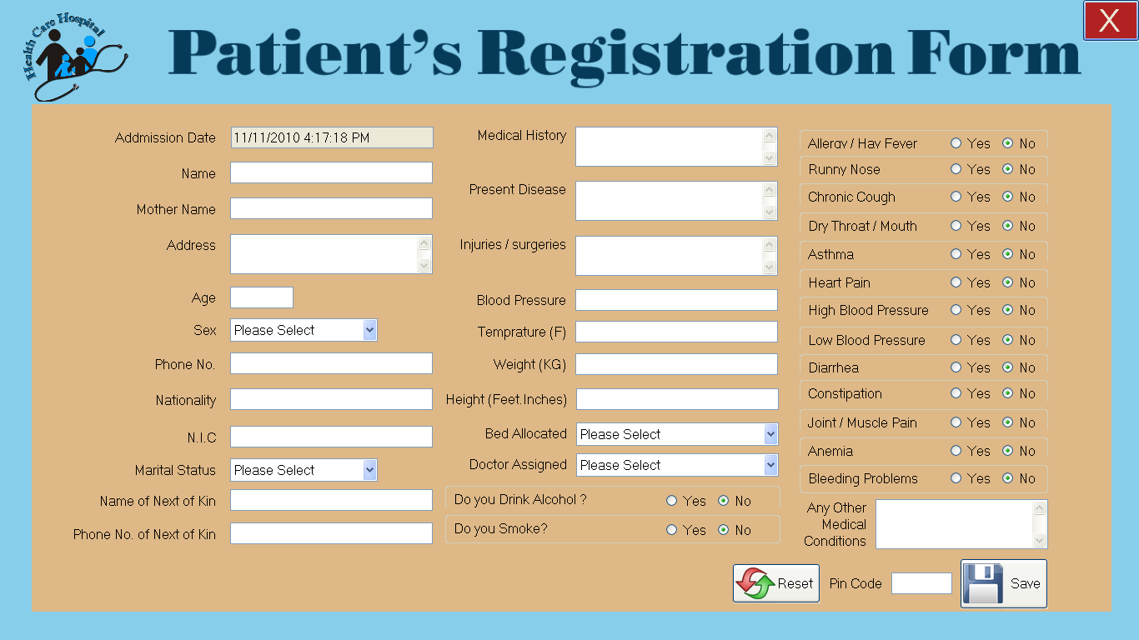

In the above screen receptionist can register a new patient by filling the fields, receptionist ca leave NIC, Medical History, Injury Surgery, Any other medical condition IF not required?

After filling the fields receptionist has to enter his/her pin code to save the record, on a valid pin code system will admit a new patient and shows a message of “Patient successfully registered and patient id is = ‘The auto generated id’”.

After the message system will open the printable report of newly admitted patient and receptionist has to print the report to attach the report in to the file of the patient.

Patient Registered

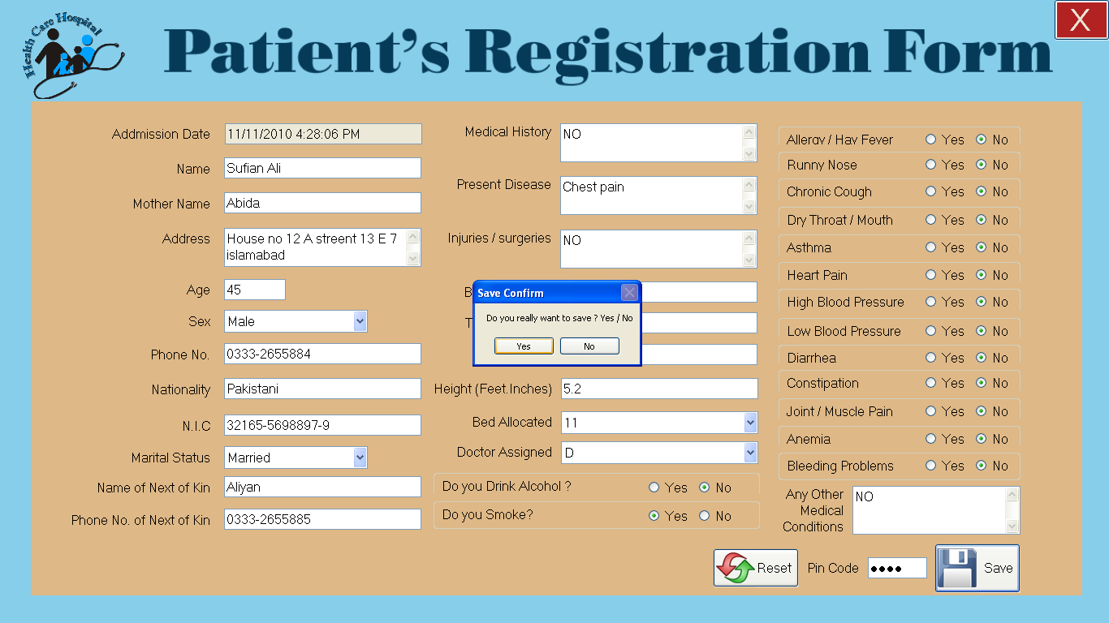

Upon filling the form like above receptionist have entered the pin code and clicked save the above message box is shown that are you really want to save the record if receptionist click yes he / she will see the following message that patient registered and id is “Generated ID”
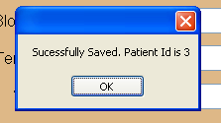

Patient Registered printable report

After registering the patient receptionist will see the printable report as follows.

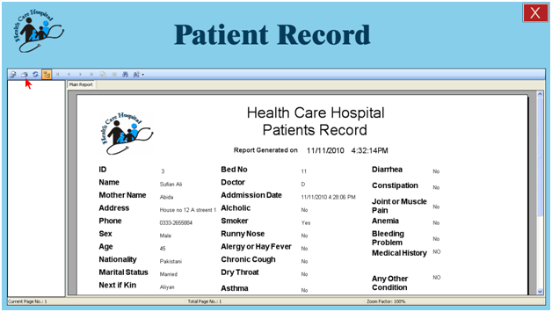
Arrow is pointing to the print button when clicked it will print the report. Sample of printed report is attached.

Discharge a patient

In the discharge form here receptionist can discharge a admitted patient by entering patient’s ID

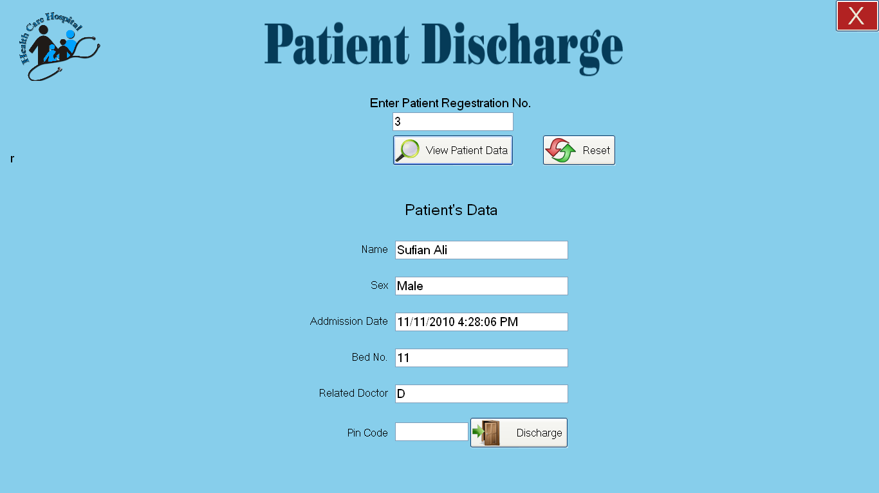

After entering the ID in registration box then click the “view patient data” button to view the patient name and bed no to confirm that it is the patient you wish to discharge.

After confirmation enter the receptionist pin code and click “discharge” button to discharge the patient. The patient will be discharged and will no longer be seen in doctor’s panel and in nurse’s panel.

Following screen will be seen after clicking the discharge button

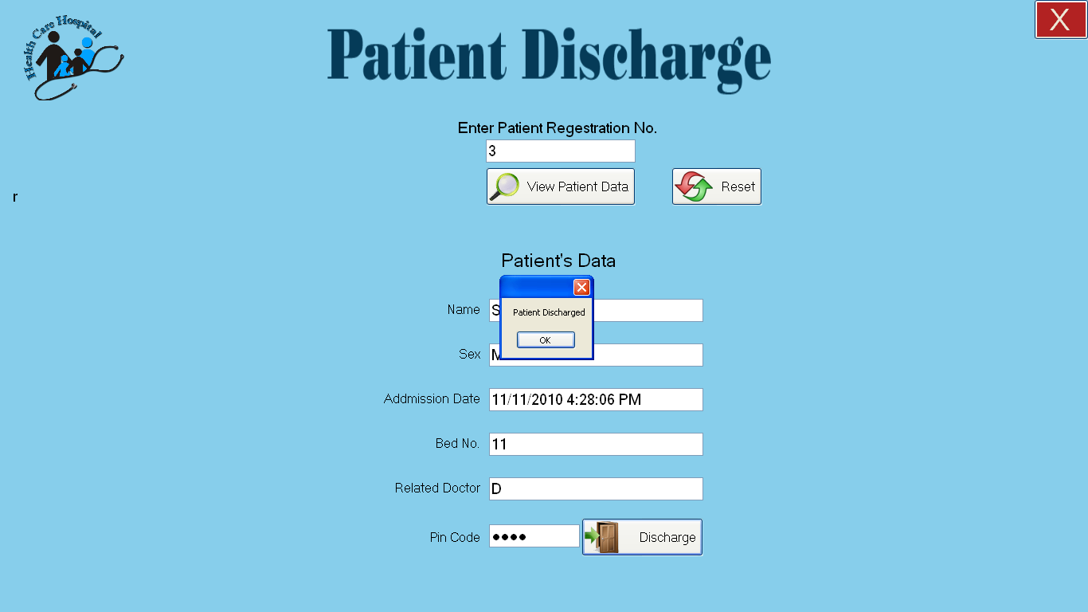

Reception My Account

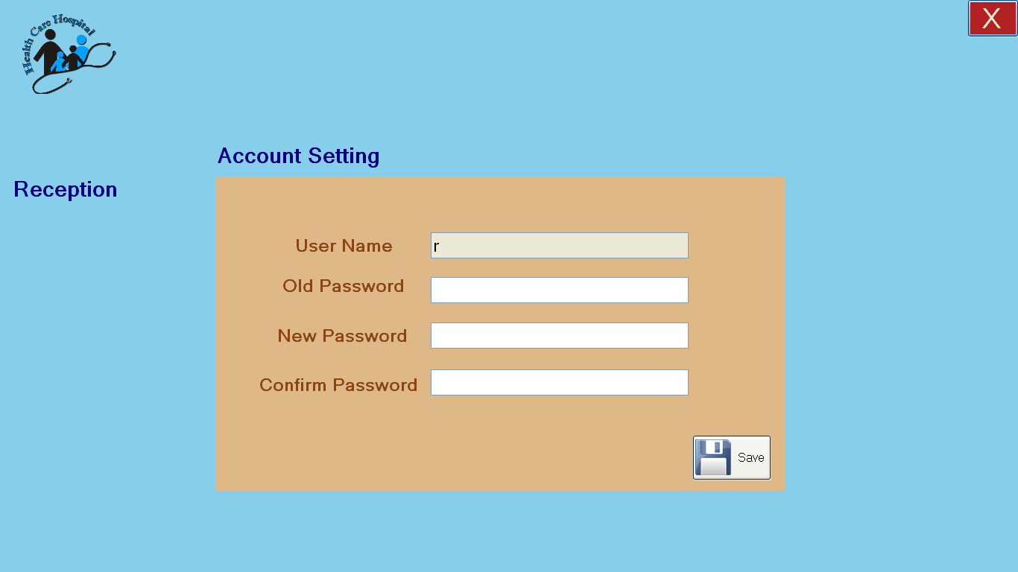

The above screen will be shown for reception to change his/her password

Nurse Panel

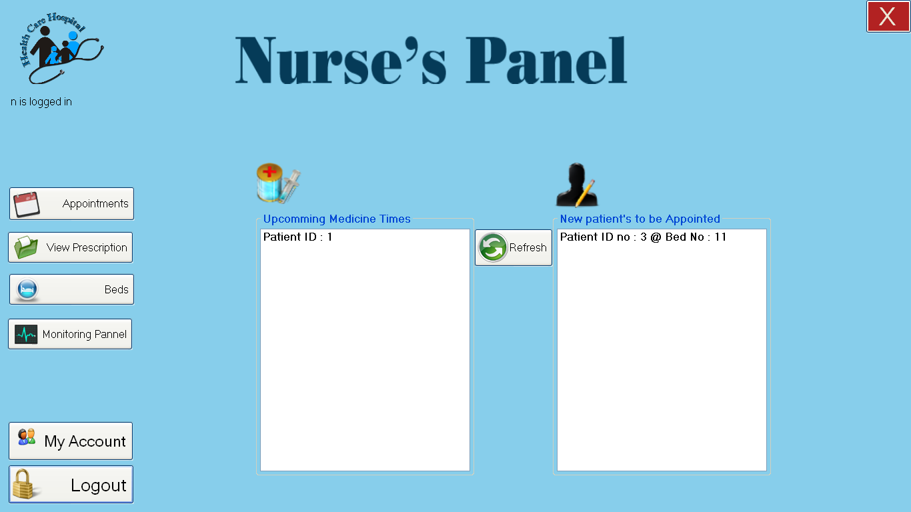

After logging in with the nurse account nurse can see the above screen. He/she can view the upcoming timings of the medicines and new patients to be appointed.

- He/she can do the following tasks: -
- Can give an appointment to a patient by selecting the “Appointments” button.
- Can view the medical prescription of specific patient upon entering the ID
- Can monitor all the patients in the ward
- Change the password by clicking the “My Account” button
- Can Log out

Appointments

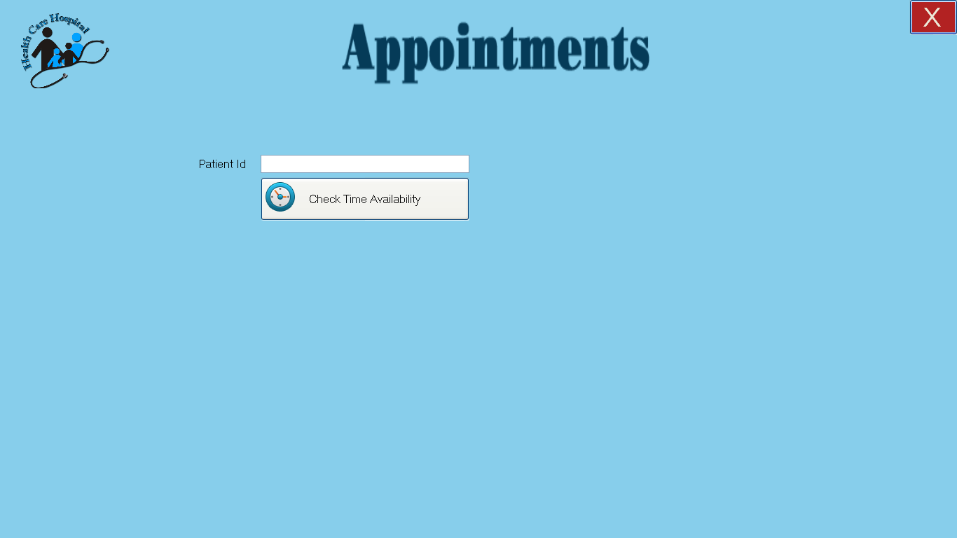

He/she can appoint a patient by entering the id of the patient in the system, if a patient is already appointed the following screen will be shown that “Patient already appointed”.

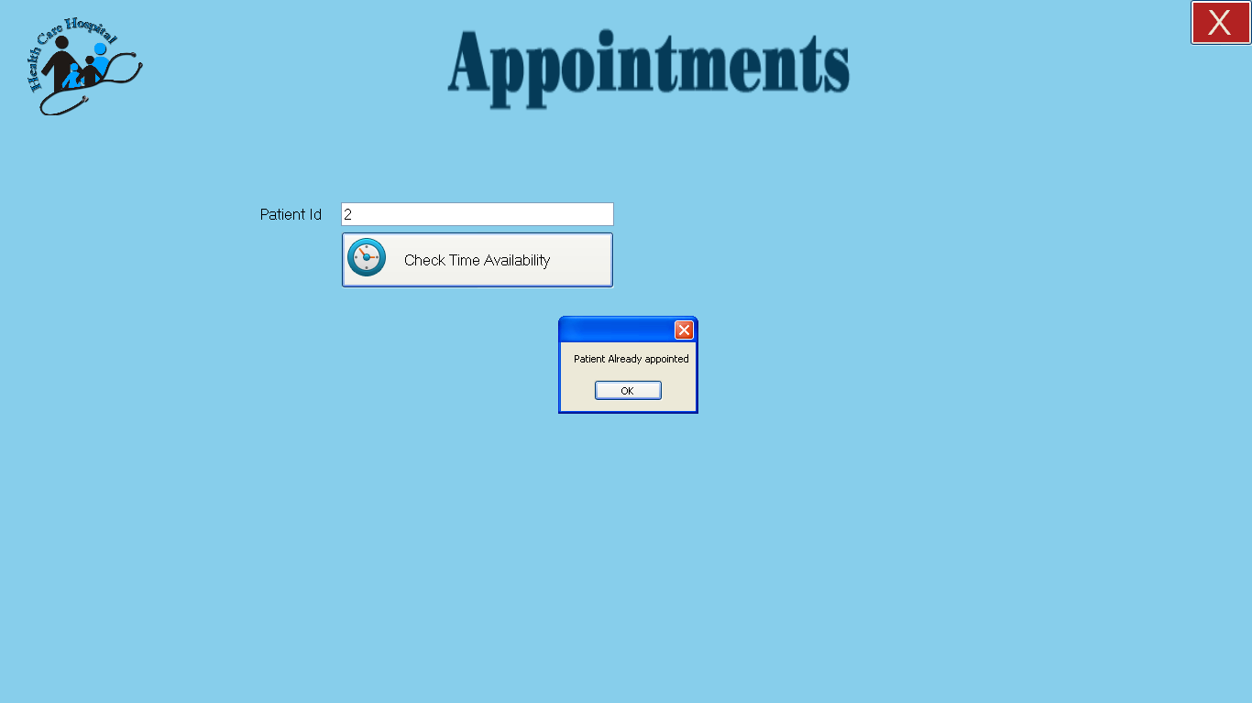

If he/she enters a wrong or invalid patient id to appoint the system will show the following screen showing that “Patient ID does not exist”

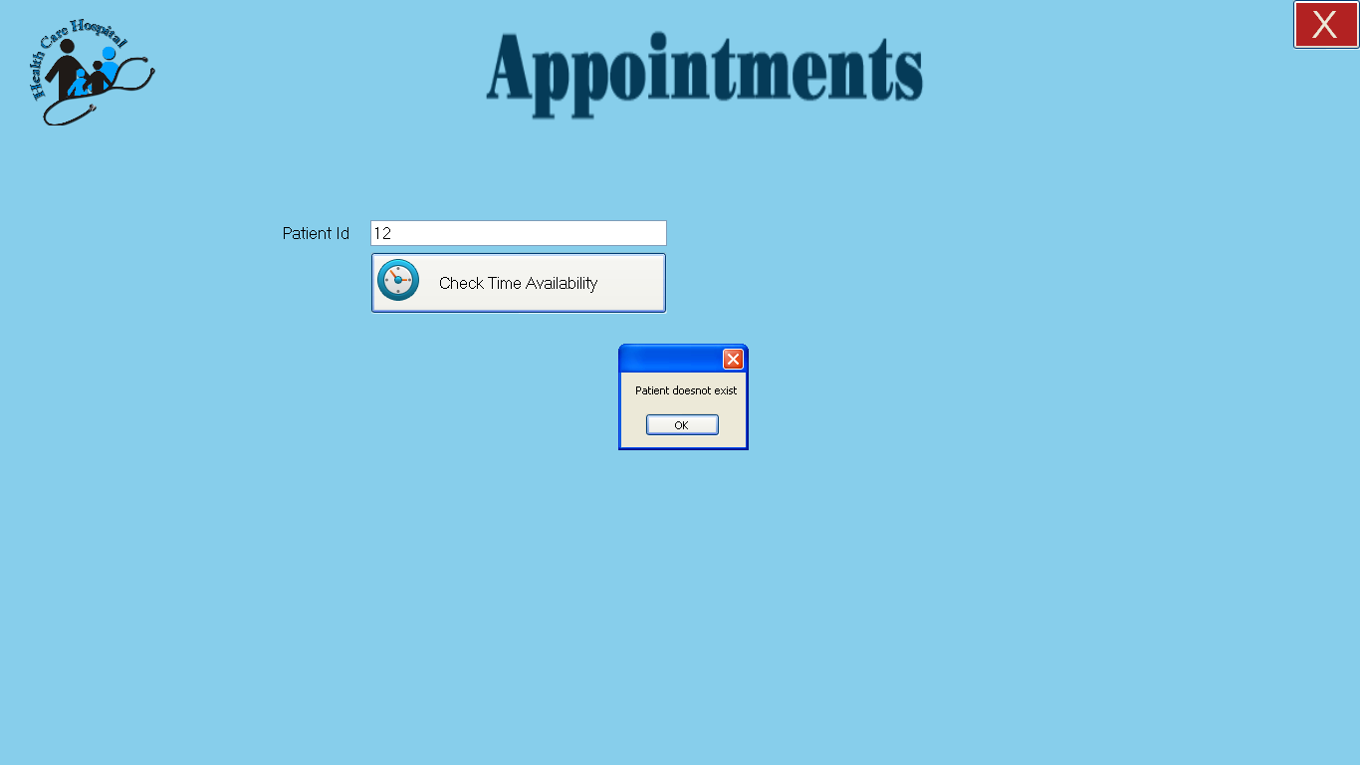

Upon entering the correct ID the following form will be shown

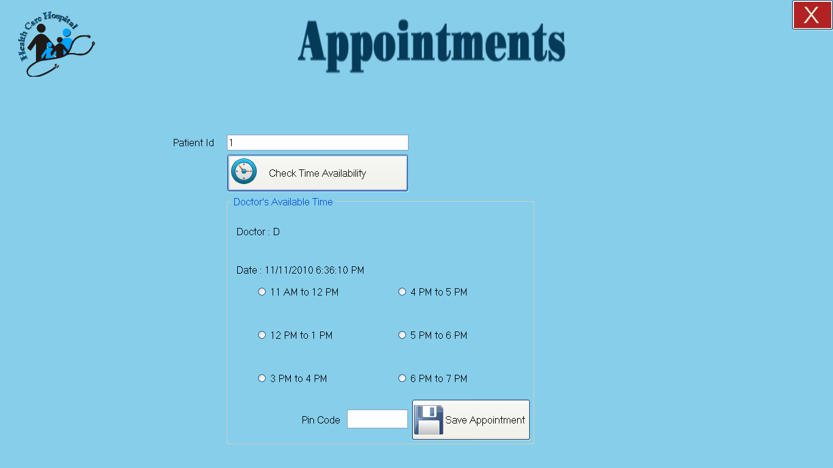

In the above screen the patient’s Doctor is shown.

Free time is also shown in the from here receptionist can select any time and save an appointment after entering pin code and it will be viewed to the doctor.

If a time is given to any patient before that time in the form will be disabled like in the following form 11 Am to 12 Pm is disabled

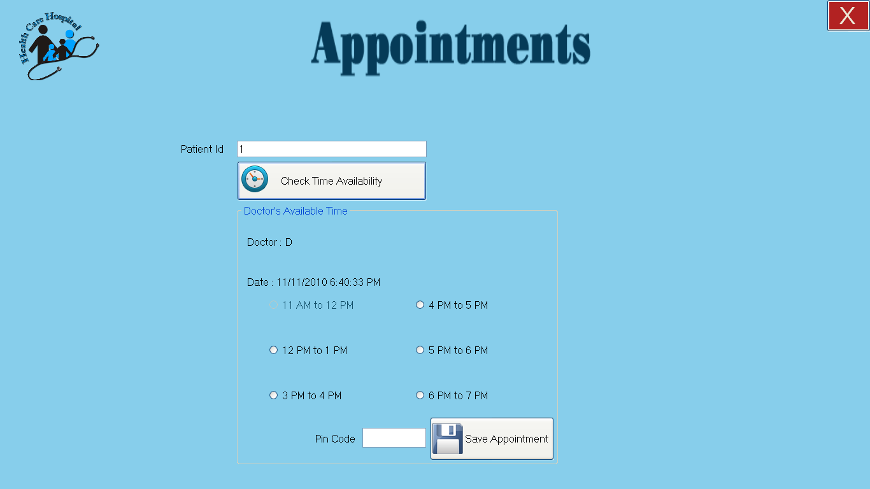

Prescription

By clicking the “prescription” button the user will see the following screen in which user can see the medicines of a patient.

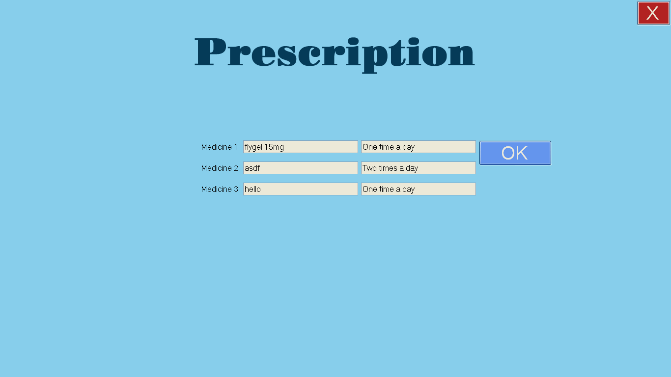

The Monitoring Panel

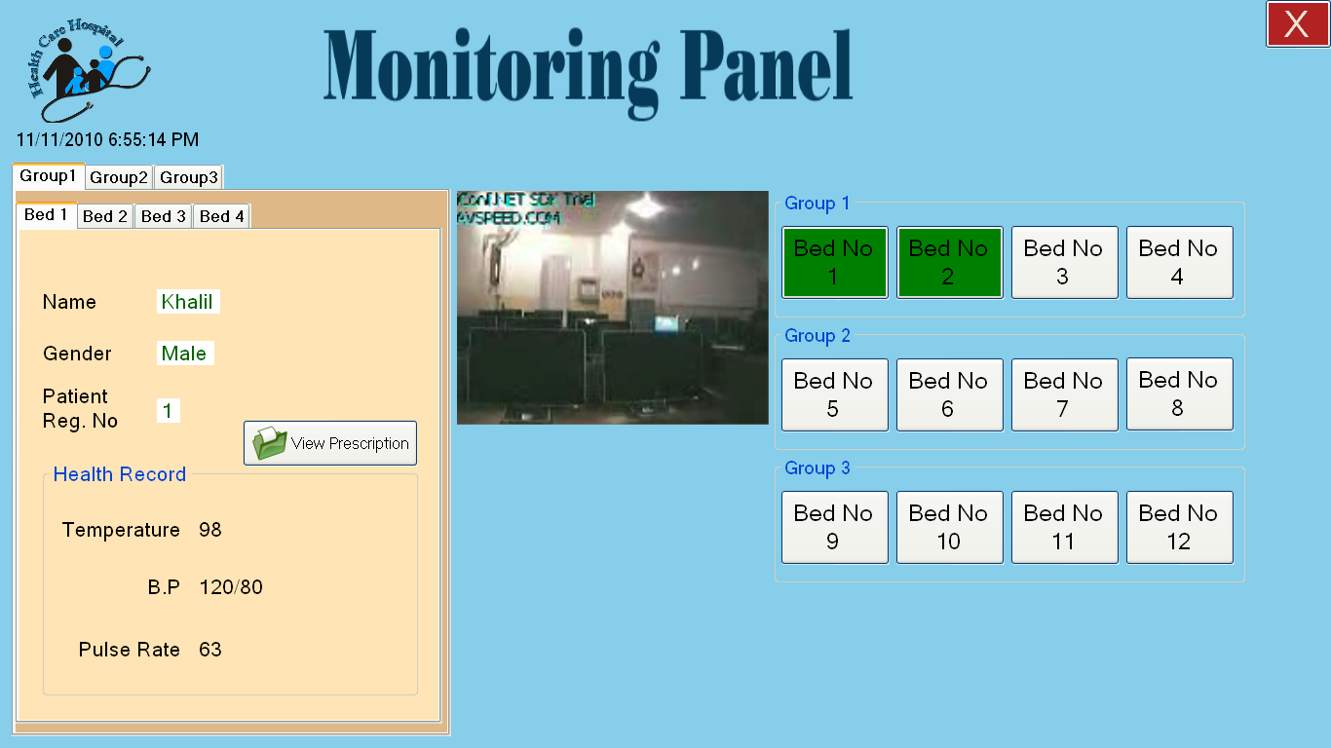

The above screen is the main part of our project that is “Monitoring Panel” here user can monitor all the patients and can see the live data of the patients. By clicking on the buttons on the right side of the screen user can switch to other patients. If there is no patient on a particular bed user will not see the live data but he/she can see the live video of the bed ( for spying purpose ).

“View prescription” button will lead the user to the information of medicines of the particular patient.

The Monitoring Panel (Monitoring Abnormality)

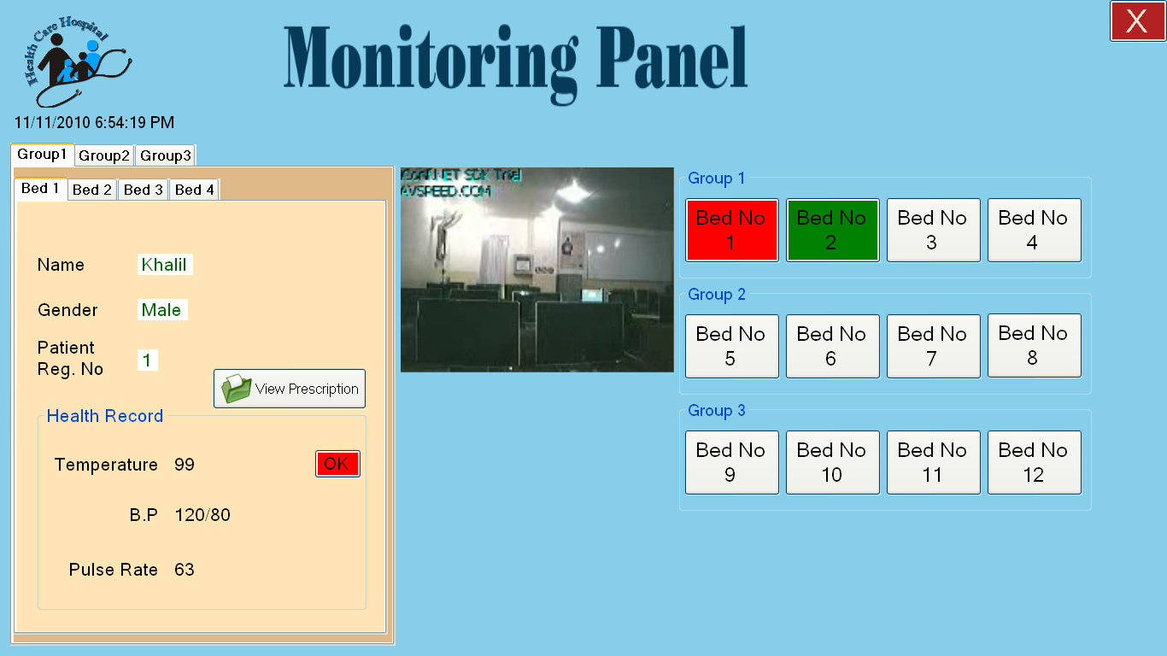

In the above screen patient at bed 1 is having abnormality in temperature. Here nurse will act upon it. The patient can be accessed by his/her bed no, if an abnormality in the live data occurs that particular bed will blink in red/green color so that user can see the abnormal condition easily, the system will produce a beep sound also so that nurse can respond to that and easily check that where the abnormality is occurred.

The system will show the parameter in which the abnormality is occurred in above example temperature is rising from the normal range. And a button of ok is shown against it. If nurse responds and click the ok button the system will consider that nurse have acknowledged and has taken the appropriate actions for the patient to bring the patient into normal condition. Then the color of the button will get back to Green indicating that the patient is normal as shown in the picture in 7.3.3

My Account

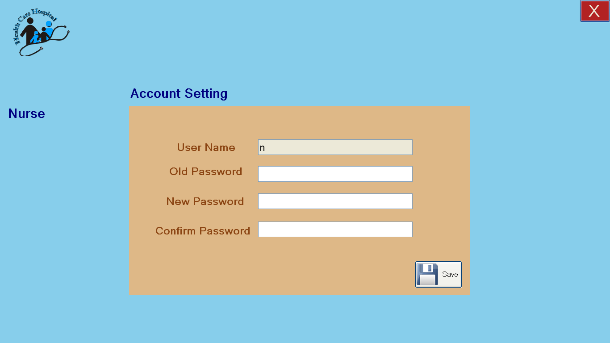

In the above screen nurse can change his/her account password.

Administrator Panel

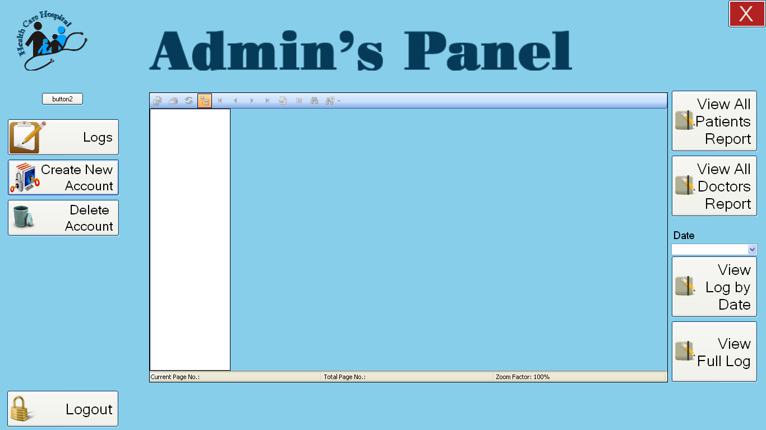
Time

The Administrator panel will look like the above screen in which Administrator can do the following actions:
- View the Logs/Reports
  - All patients that are admitted
  - All doctors
  - View the login logout details by date
  - View all login logout details
- Create a new account of:
  - Nurse
  - Doctor
  - Receptionist
- Delete an account of:
  - Nurse
  - Doctor
  - Receptionist

All Patients Report

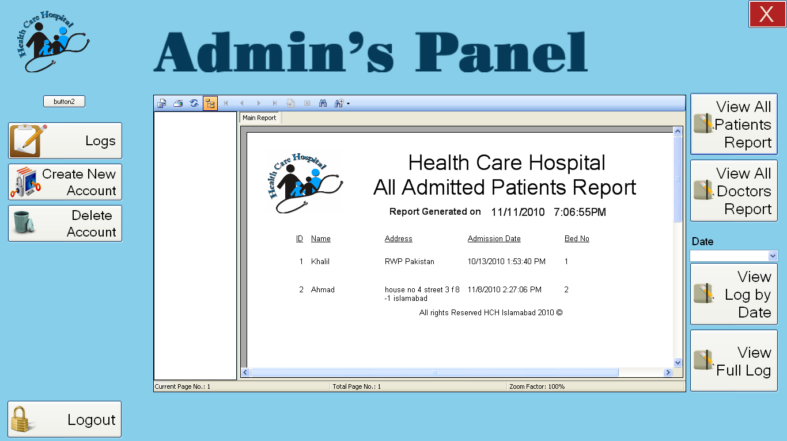
Time

The system will show all the patients that are currently admitted in the ward. User can print it by clicking on print. A sample printed report is attached.

All Doctors Report

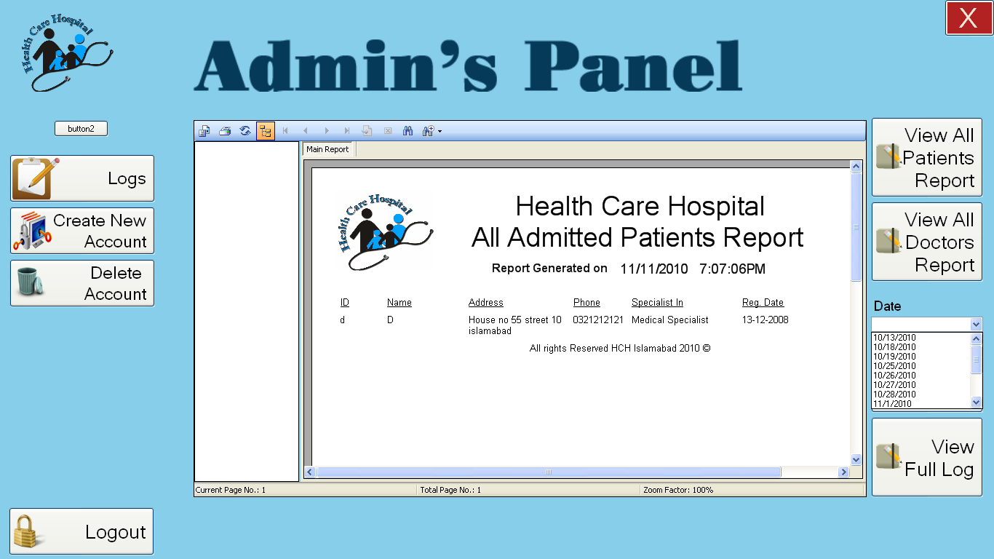
Time

This report will give the information of all the doctors in the hospital.

Login Logout Report by Date

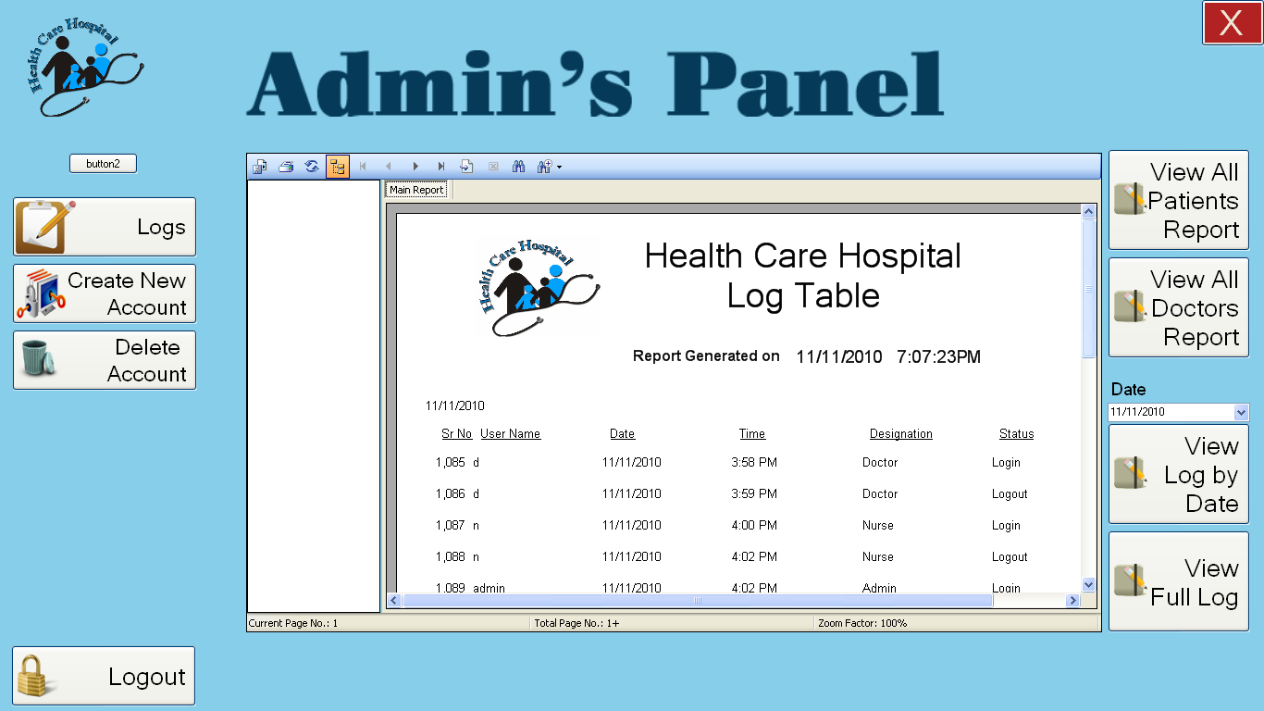
Time

The user have to select a date (arrow is pointing to the date box in the screen shot) the click the view log by date button the system will show the report of those users who have logged in and logged out on that particular date.

Full Login Logout Report

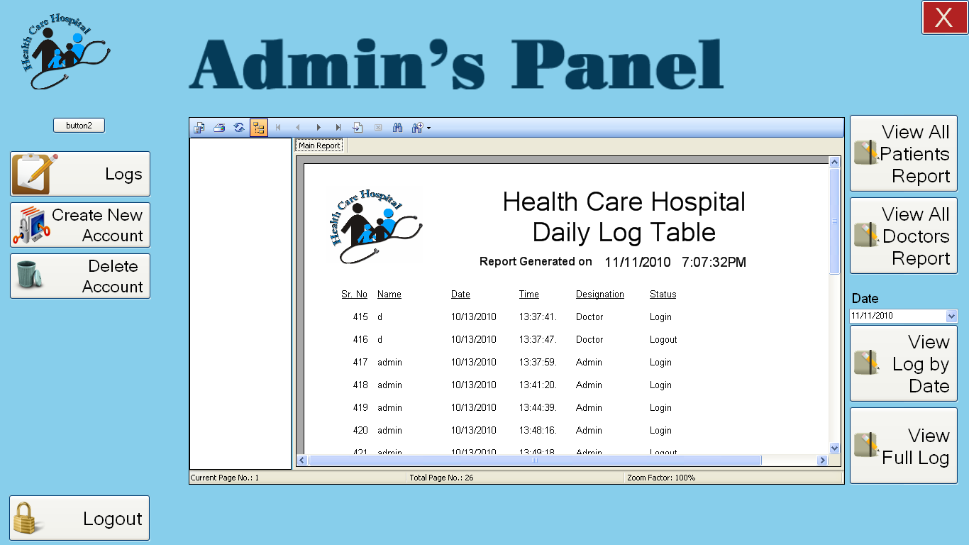
Time

The user can view the full log of the login logout details any time by clicking the full log button the system will show the full login logout details as shown in the above screen shot.

Create a new Account

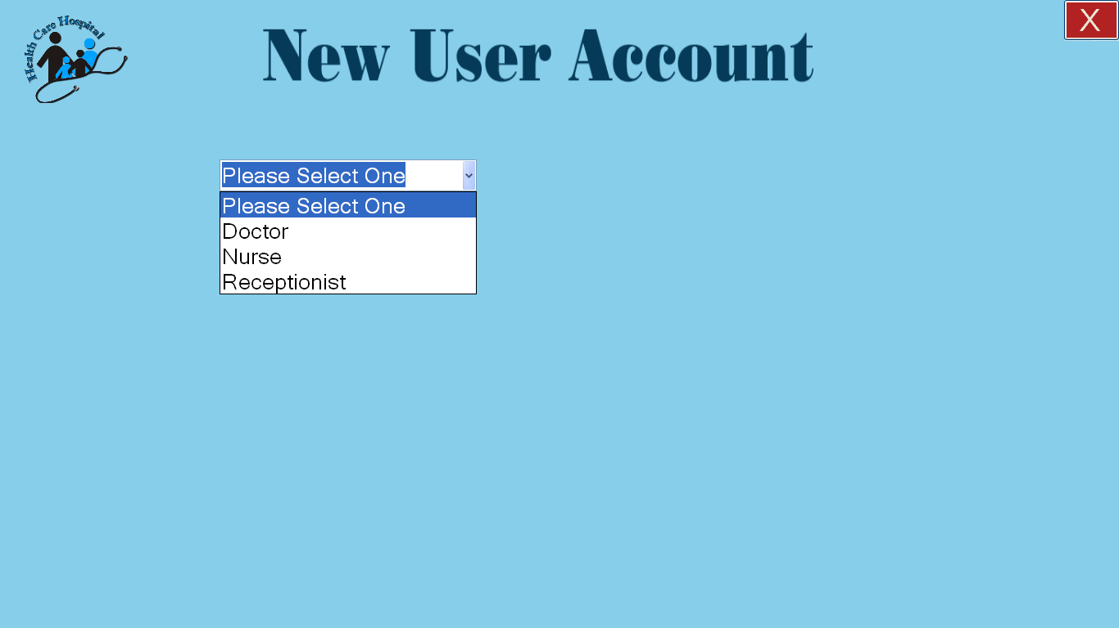

Administrator can create a new account of (Nurse, Doctor and Reception).

Administrator will select the account type to create a account as shown in the screen shot.

Create a new Doctor Account

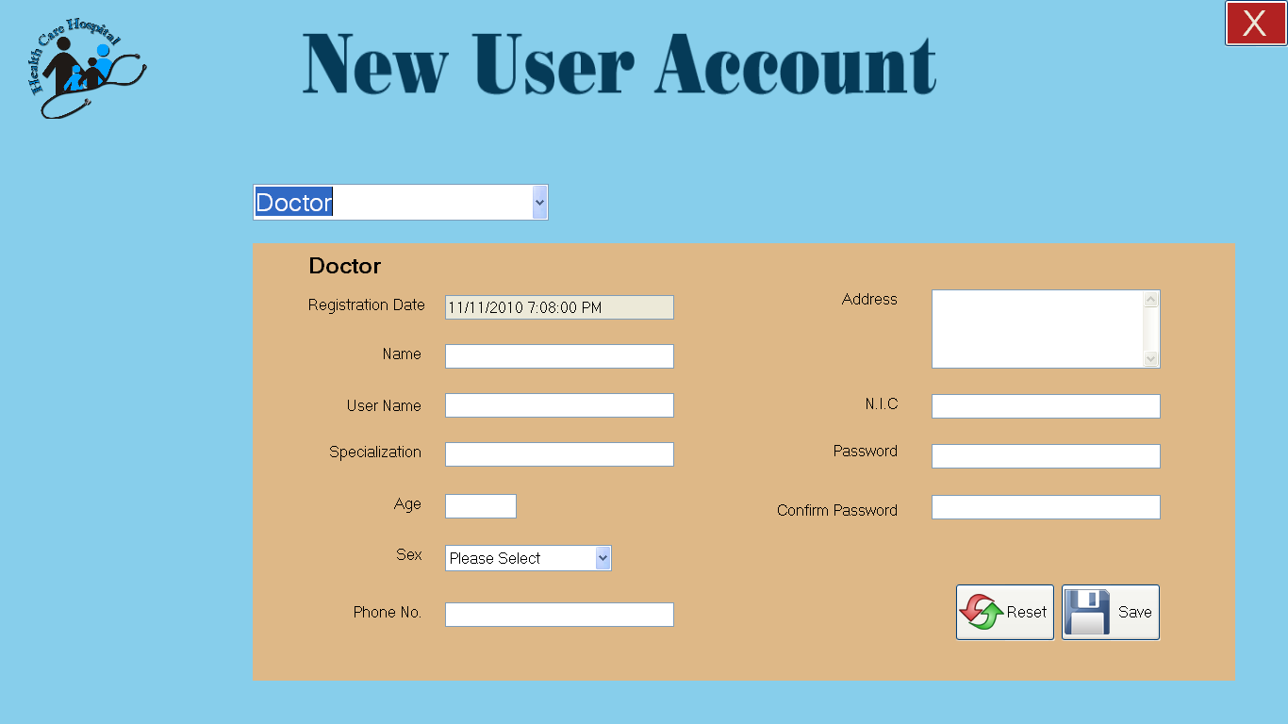

By filling all the field and clicking save button will create a Doctor account for a new Doctor.

Reset button will clear all the fields when pressed.

Create a new Nurse Account

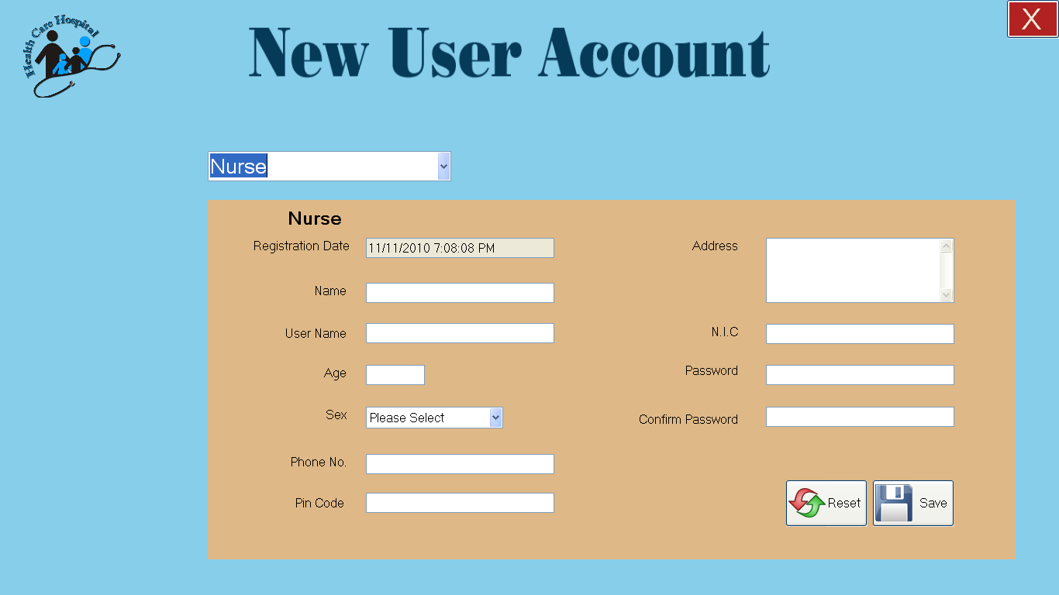

By filling all the field and clicking save button will create a Nurse account for a new Nurse.

Reset button will clear all the fields when pressed.

Create a new Reception Account

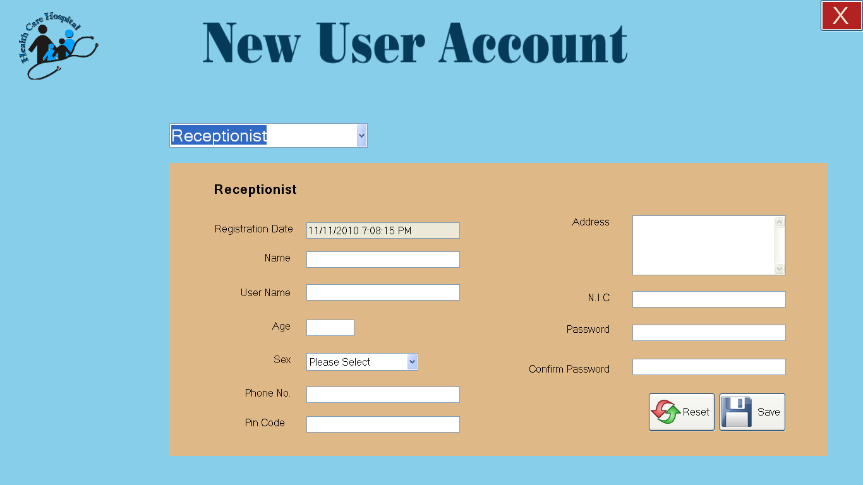

By filling all the field and clicking save button will create a Receptionist account for a new Receptionist.

Reset button will clear all the fields when pressed.

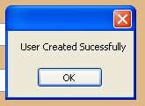

In the create account form when save is pressed after entering all the fields will display the above message.

Delete Account

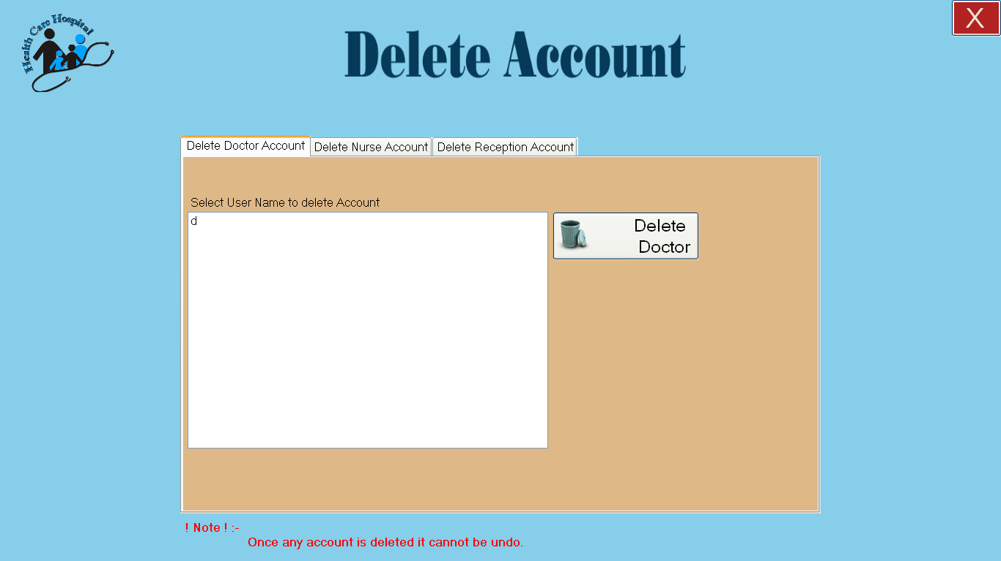

Delete account will show the above screen and system will show the existing users in the list box. Doctor’s account will be shown in the doctor tab, nurse account in nurse tab and receptionist account in receptionist tab.

Screen of delete nurse account and delete receptionist account are as follows:

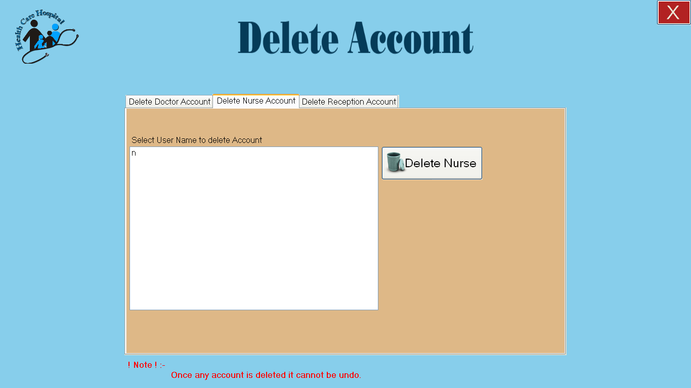

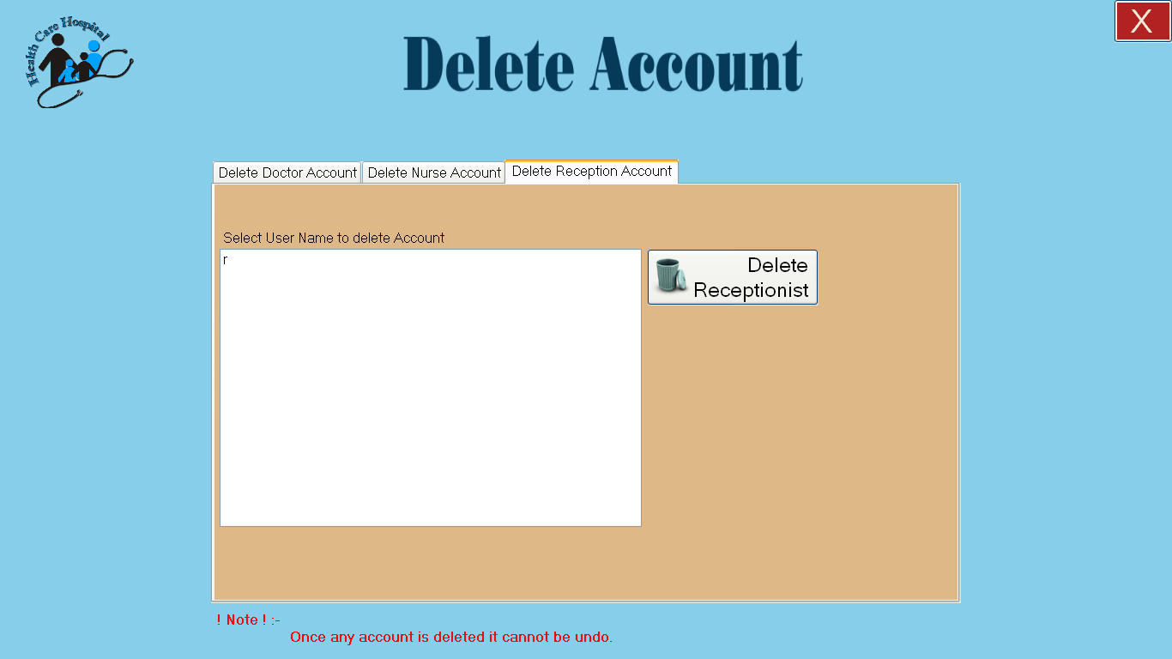

After deleting an account user will see the following screen.
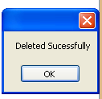

If user press delete button without selecting any account the system will show a message as follows:
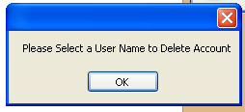

CHAPTER # 8

Sample Reports

CHAPTER # 9

Future Enhancements

Video Monitoring with Motion Detection

In our software the patient is monitored by simple live video, to enhance the security of the patient video can be implemented with motion detection, so that if somebody comes near to the patient the camera will detect the motion and starts recoding. Alarm at the time of any movement can also be generated for faster actions.

Account Details

Currently our software has no billing module, so billing module is another feature to be added in future.

Scope of Medical Sensors

The project has been designed for all of the medical sensors such as Heart Rate, Blood Pressure, Sugar etc but due to lack of funds we have completed our project with three sensors but our project can be enhanced by integrating more sensors.

Web based Software

Trends are for self-health care, patients perform simple tests at their home and save the record online in Electronic Patient Journal where further actions are performed to get out the health results. Currently our software is working on Local Area Network (LAN), in future it can be modified to make it work from internet, and this feature will increase our software’s accessibility. There would be need of more resources such as faster internet without disconnections, static IPs.

Case Study of Shifa Hospital (Dialysis Department)

Our software can be modified for the dialysis department of Shifa International Hospital Islamabad, a brief thesis is presented here to understand that how our software can be modified.

This case study is about the research of dialysis department of Shifa International hospital.

What is Dialysis

Dialysis is a process whereby impurities and toxins are removed from the body by a machine. This procedure is done on patients whose kidneys are not working to perform this function properly.

In general, the kidneys (each person has two, one left and one right) to filter the blood. All day long, the heart pumps blood through the kidneys. Much of the material in the blood, including proteins and cells, are too large to pass through the filter system of the kidney, and remain in the bloodstream. Small molecules do pass through the kidney's filter system. These include water, dissolved salts (called ions), and other metabolites. Much of these materials are reabsorbed by the kidney into the bloodstream, to keep the body working properly (the salt concentration of the blood must be kept just right at all times). Any materials that are not needed are sent out of the kidney as urine. Urine travels from the kidney via the ureters to the bladder, where it is temporarily stored until we go to the bathroom.

Working of dialysis Machine

Dialysis is a way for a machine to perform the same function as the kidney, when someone's kidneys are failing. If a person is having kidney failure, and does not get dialysis, the body will not be able to remove waste products from the blood, or be able to maintain proper salt concentration of the blood. The person will get very sick, and can eventually die.

The Dialysis Machine

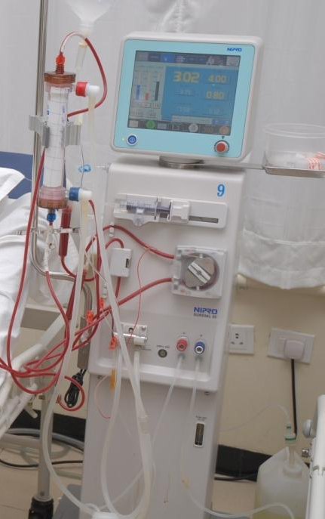

Problem Description:

The dialysis department of Shifa International hospital is equipped with about 40 dialysis machines having 40 patients for 4 hour treatment. The room of doctor is far away from dialysis room due to this reason doctor feel difficult to go to the dialysis room and check every patient while checking his regular patients.

While in case of emergency there is no mechanism to inform the doctor about the emergency in dialysis room. Sometimes doctors could be on leave so they can’t check their patients. We consulted the doctor of Shifa International Hospital Doctor told us about the following problems of their Dialysis Department.

- The dialysis room is far from the doctor’s room.
- No remote access to the dialysis room.
- No online access.

Doctor’s Requirements:

Following are the needs of the doctor

- Doctor wants to check the patients while being in the office that means doctor want live video and sound of patient’s heart and breath along with the dialysis machine parameters.
- Doctor wants to communicate with the patient like he is talking to the patient directly.
- Doctor wants to access his/her patients from the web also.

Problem Solution:

Solution of the problem is to implement software that will monitor the dialysis room and records information.

Our software can be implemented in Shifa International Hospital’s Dialysis Department which will include the following features
Live video of patient along with voice to communicate with the patient
- Dialysis parameters
- Intelligent agents
- Alarms for the doctors and nurses in case of emergency
- Web based implementation of the software
- Sms notification in case of emergency

Demo Interface

A demo interface presenting the doctor’s panel in Shifa Hospital.

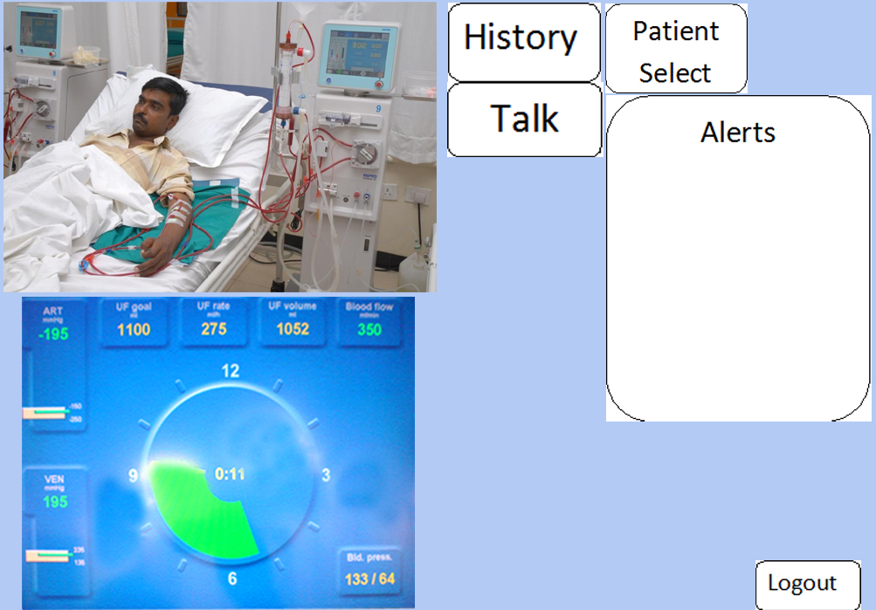

References

Websites:

[1] http://www.avspeed.com/avcontent/iconf-net-video-conferencing-sdk

[2] http://en.wikipedia.org/wiki/Spiral_model

[3] http://en.wikipedia.org/wiki/.NET_Framework

[4] http://en.wikipedia.org/wiki/SQL_Server_Management_Studio

[5] http://en.wikipedia.org/wiki/Unified_Modeling_Language

[6] http://en.wikipedia.org/wiki/Use_case_diagram

[7] http://en.wikipedia.org/wiki/Database_design

Research Papers:

[1] Security for pervasive medical sensor networks
This paper appears in: Mobile and Ubiquitous Systems: Networking & Services, MobiQuitous, 2009. MobiQuitous '09. 6th Annual International
Issue Date : 13-16 July 2009
On page(s): 1 - 10
Location: Toronto, ON
Print ISBN: 978-963-9799-59-2
INSPEC Accession Number: 10974744
Digital Object Identifier : 10.4108/ICST.MOBIQUITOUS2009.6832
Date of Current Version : 10 November 2009
[2] Wireless Medical Sensor Networks in Emergency Response: Implementation and Pilot Results
This paper appears in: Technologies for Homeland Security, 2008 IEEE Conference on
Issue Date : 12-13 May 2008
On page(s): 187 - 192
Location: Waltham, MA
Print ISBN: 978-1-4244-1977-7
INSPEC Accession Number: 10057563
Digital Object Identifier : 10.1109/THS.2008.4534447
Date of Current Version : 30 May 2008
[3] Message Sending Method Using Patients' Priority for Medical Sensor Network

This paper appears in: Distributed Computing Systems Workshops, 2009. ICDCS Workshops '09. 29th IEEE International Conference on
Issue Date : 22-26 June 2009
On page(s): 194 - 200
Location: Montreal, QC
ISSN : 1545-0678
Print ISBN: 978-0-7695-3660-6
INSPEC Accession Number: 10762471
Digital Object Identifier : 10.1109/ICDCSW.2009.43
Date of Current Version : 07 July 2009

[4] Secure health monitoring using medical wireless sensor networks

This paper appears in: Networked Computing and Advanced Information Management (NCM), 2010 Sixth International Conference on
Issue Date : 16-18 Aug. 2010
On page(s): 491 - 494
Location: Seoul
Print ISBN: 978-1-4244-7671-8
INSPEC Accession Number: 11530934
Date of Current Version : 16 September 2010
[5] Remote Healthcare Monitoring System Architecture using Sensor Networks

This paper appears in: Region 5 Conference, 2008 IEEE
Issue Date : 17-20 April 2008
On page(s): 1 - 6
Location: Kansas City, MO
Print ISBN: 978-1-4244-2076-6
INSPEC Accession Number: 10059647
Digital Object Identifier : 10.1109/TPSD.2008.4562760
Date of Current Version : 15 July 2008

