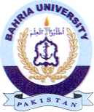
Bahria University Library Islamabad
Source: The Nation & Dunya Wednesday August 11, 2021

