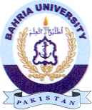
Bahria University Library Islamabad
Source: The News Sunday July 18, 2021

