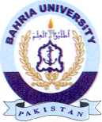
Bahria University Library Islamabad
Source: Tribune & Express Sunday June 27, 2021

