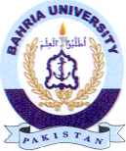
Bahria University Library Islamabad
Source: Jang Sunday June 27, 2021

