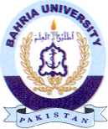
Bahria University Library Islamabad
Source: Jang Wednesday Jun 09, 2021

