
Bahria University Library Islamabad
Source: Dawn, Sunday, May 23, 2021

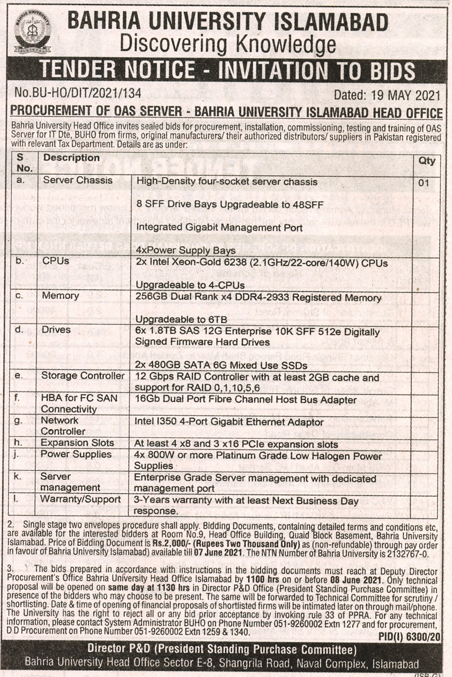

Bahria University Library Islamabad
Source: Jang, Sunday, May 23, 2021

