
Bahria University Library Islamabad
Source: The Nation, Tuesday, February 16, 2021



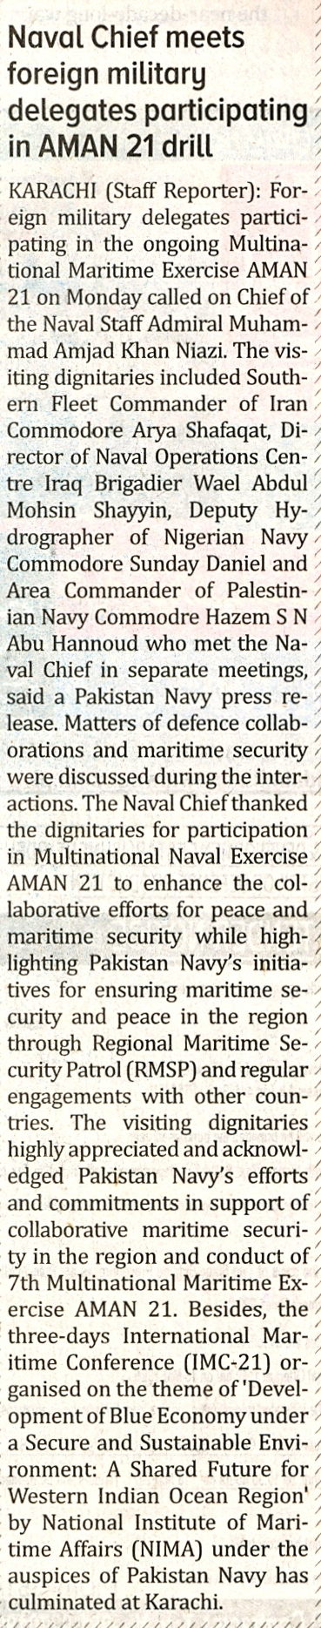

Bahria University Library Islamabad
Source: Business Recorder, Tuesday, February 16, 2021



Bahria University Library Islamabad
Source: Pakistan Observer, Tuesday, February 16, 2021



Bahria University Library Islamabad
Source: Frontier Post, Tuesday, February 16, 2021


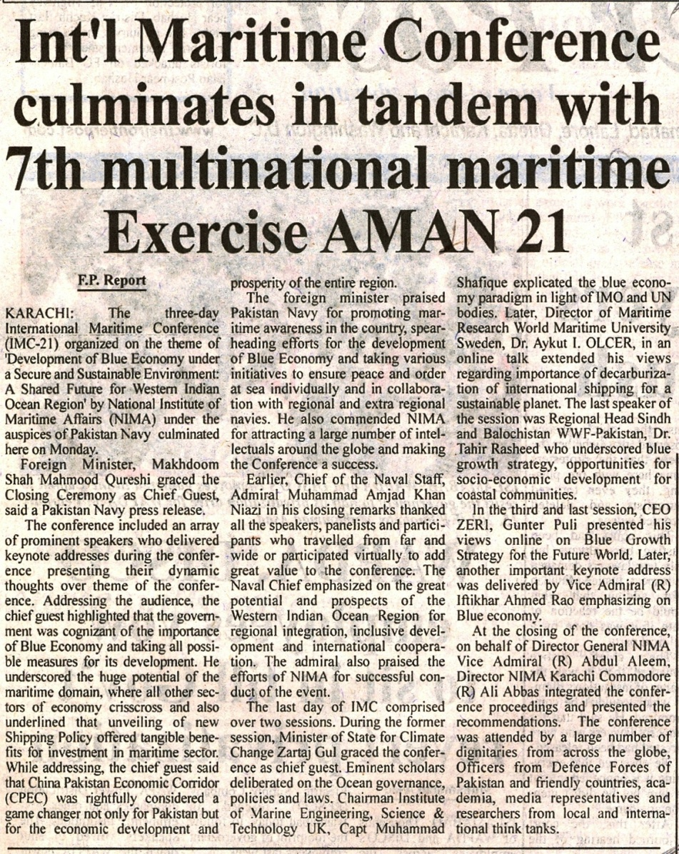

Bahria University Library Islamabad
Source: Jang, Tuesday, February 16, 2021

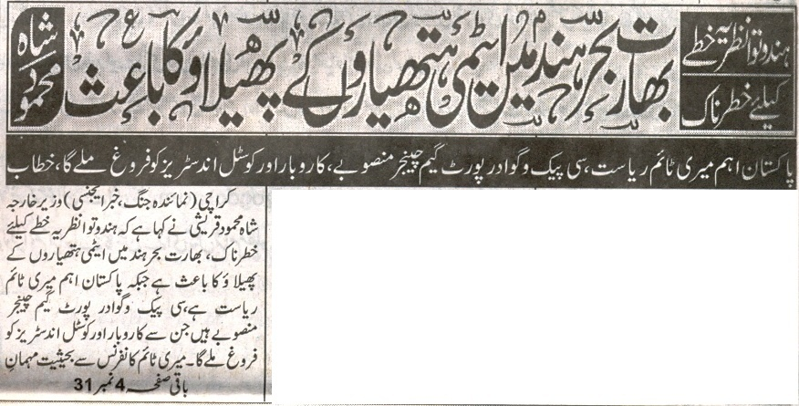
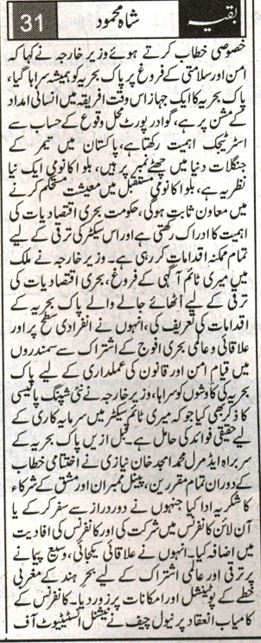

Bahria University Library Islamabad
Source: Express, Tuesday, February 16, 2021

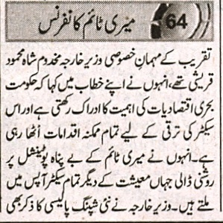
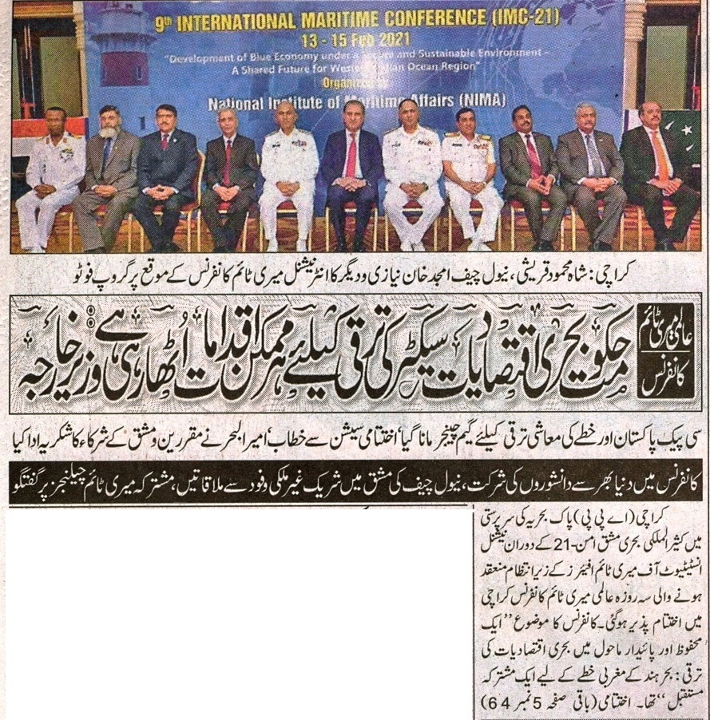
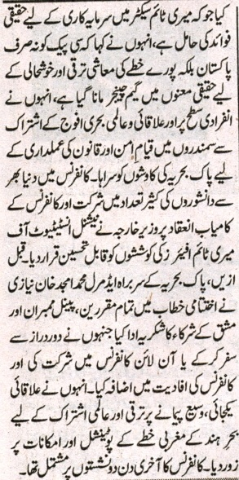

Bahria University Library Islamabad
Source: Duniya, Tuesday, February 16, 2021

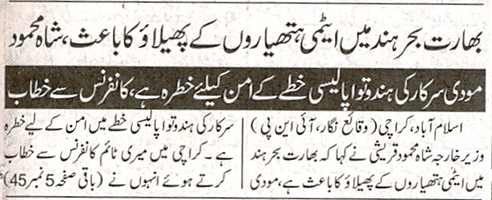
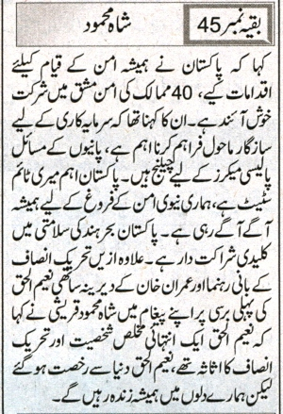

Bahria University Library Islamabad
Source: Nawa-i-Waqt, Tuesday, February 16, 2021

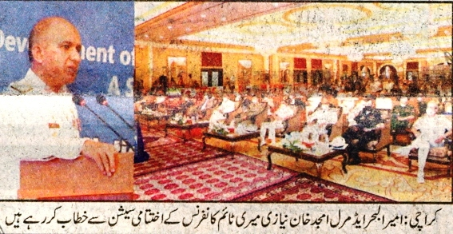
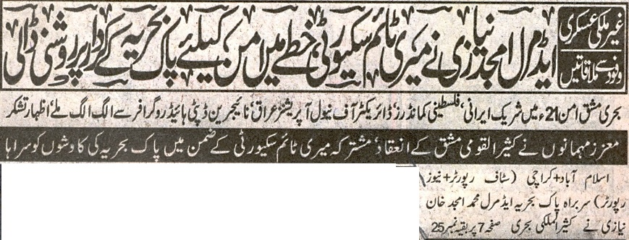
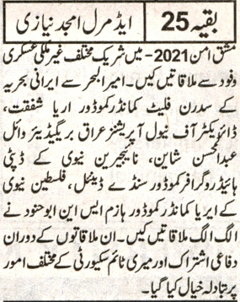

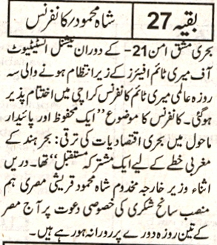
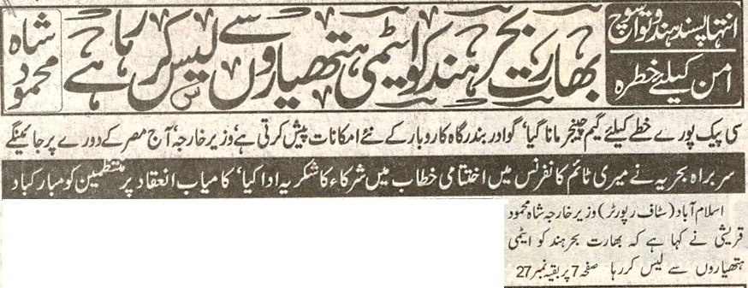

Bahria University Library Islamabad
Source: Nai Baat, Tuesday, February 16, 2021

