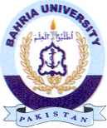
Bahria University Library Islamabad
Source: The News Sunday February 07 2021

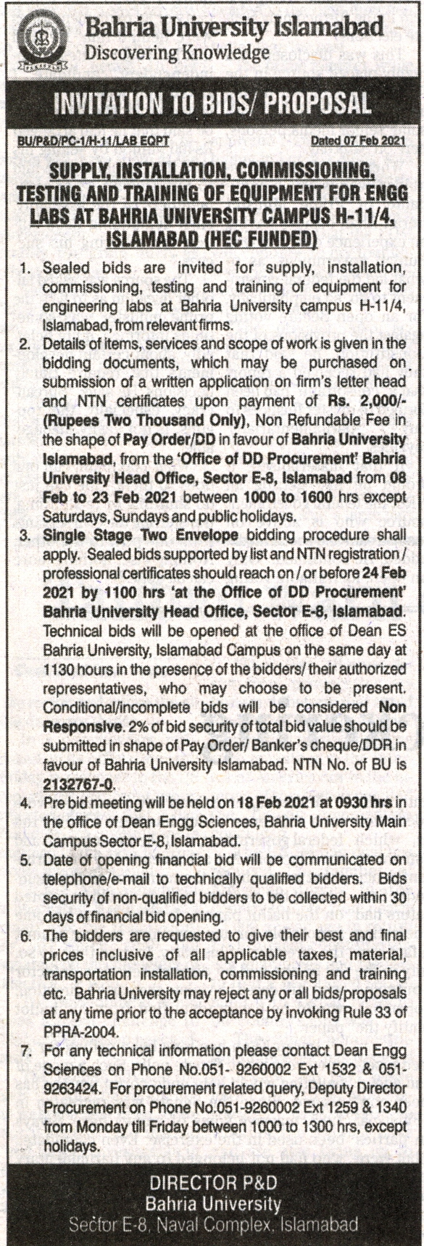

Bahria University Library Islamabad
Source: Jang Sunday, February 07 2021

