
Bahria University Library Islamabad
Source: Dawn Wednesday February 03, 2021

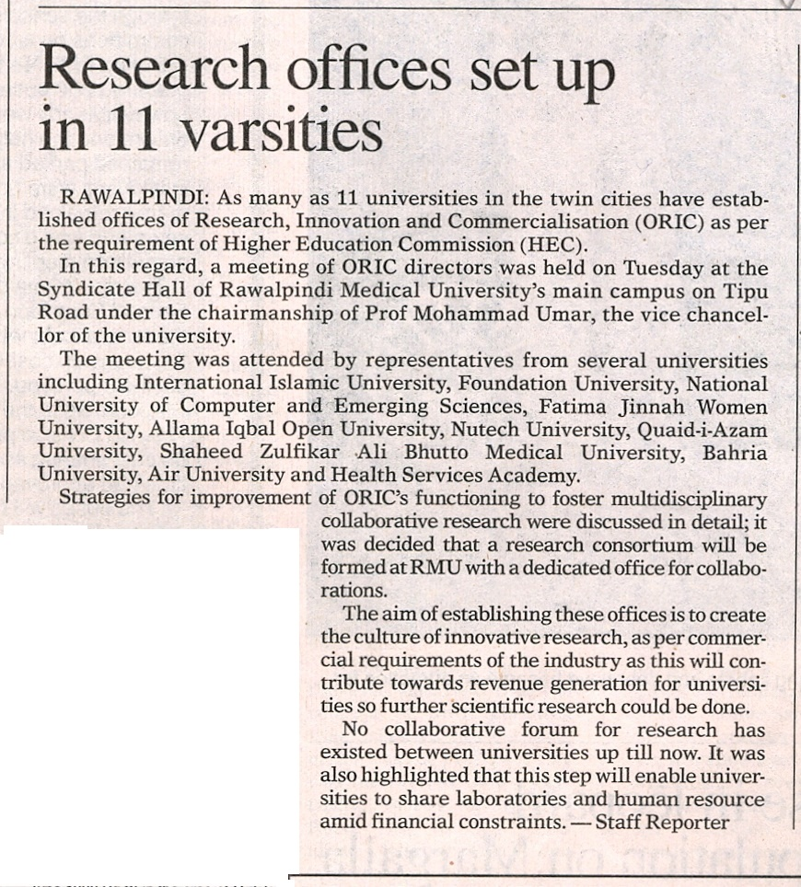

Bahria University Library Islamabad
Source: Jang Wednesday February 03, 2021

