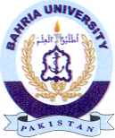
Bahria University Library Islamabad
Source: The News Tuesday February 02,2021

