
Bahria University Library Islamabad
Source: Pakistan Observer Wednesday February 03, 2021

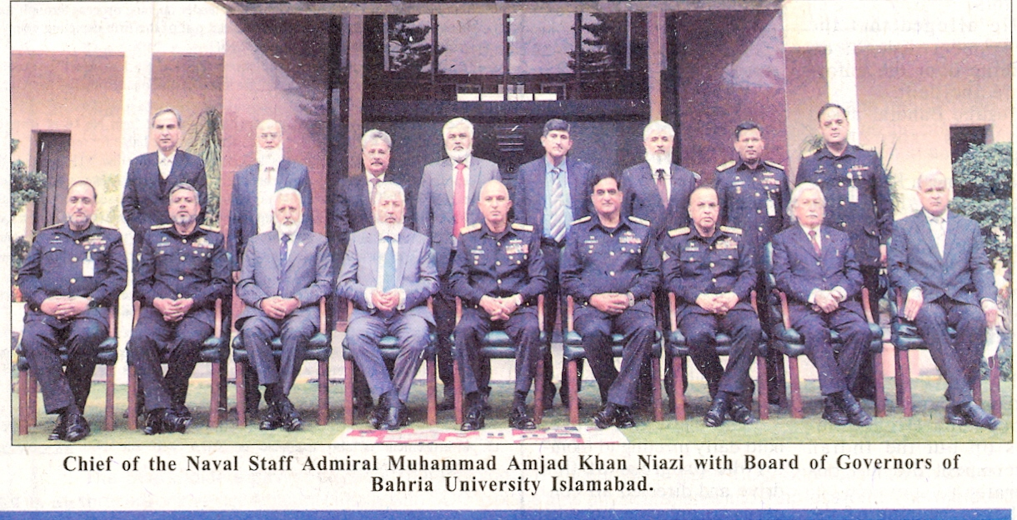

Bahria University Library Islamabad
Source: The Nation Wednesday February 03, 2021

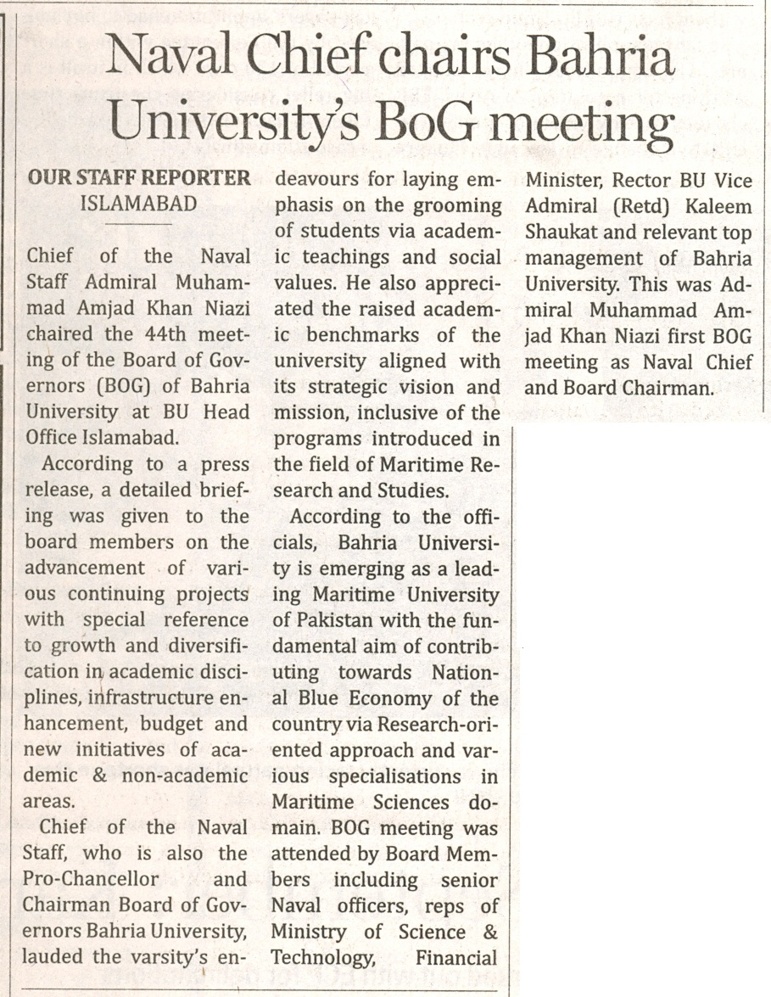

Bahria University Library Islamabad
Source: Jang Wednesday February 03, 2021

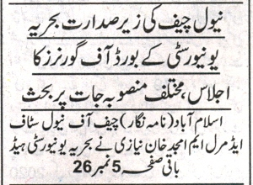
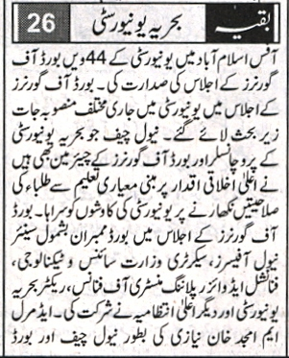

Bahria University Library Islamabad
Source: Express Wednesday February 03, 2021

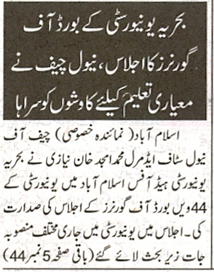
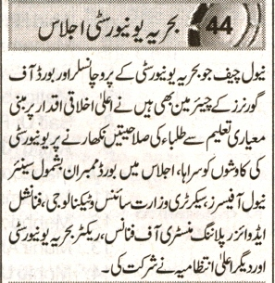

Bahria University Library Islamabad
Source: Duniya Wednesday February 03, 2021

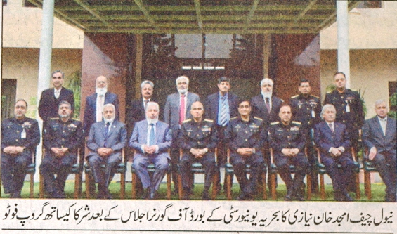
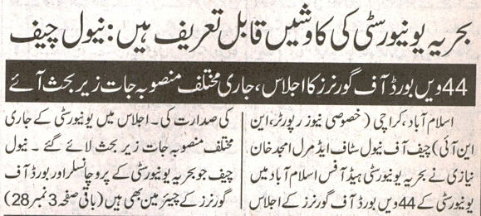
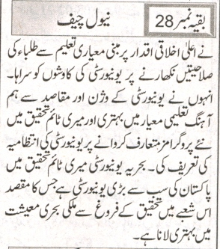

Bahria University Library Islamabad
Source: Nawa-i-Waqt Wednesday February 03, 2021

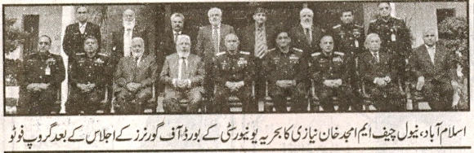
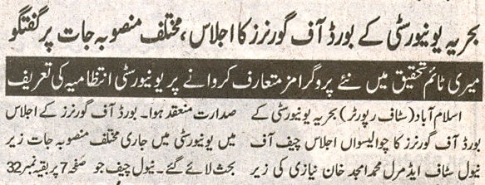
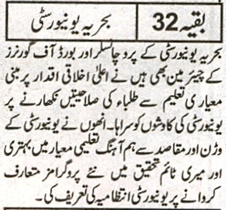

Bahria University Library Islamabad
Source: Nai Baat Wednesday February 03, 2021

