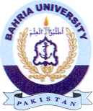
Bahria University Library Islamabad
Source: Pak Observer Friday January 29, 2021



Bahria University Library Islamabad
Source: Express Friday January 29, 2021

